UNITED STATES

SECURITIES AND EXCHANGE COMMISSION
Washington, D.C. 20549

FORM 8-K

CURRENT REPORT

Pursuant to Section 13 or 15(d)
of the Securities Exchange Act of 1934

Date of Report (Date of earliest event reported): August 26, 2020

Avita Therapeutics, Inc.

(Exact name of registrant as specified in its charter)

Delaware | 001-39059 | 85-1021707
(State or other jurisdiction | (Commission | (IRS Employer
of incorporation) | File Number) | Identification No.)
28159 Avenue Stanford,
Suite 220, Valencia, CA 91355 |  | 661.367.9170
(Address of principal executive offices, including Zip Code) |  | (Registrant’s telephone number, including area code)

N/A

(Former name or former address, if changed since last report)

Check the appropriate box below if the Form 8-K filing is intended to simultaneously satisfy the filing obligation of the registrant under any of the following provisions:

- Written communications pursuant to Rule 425 under the Securities Act (17 CFR 230.425)

- Soliciting material pursuant to Rule 14a-12 under the Exchange Act (17 CFR 240.14a-12)

- Pre-commencement communications pursuant to Rule 14d-2(b) under the Exchange Act (17 CFR 240.14d-2(b))

- Pre-commencement communications pursuant to Rule 13e-4(c) under the Exchange Act (17 CFR 240.13e-4(c))

Securities registered pursuant to Section 12(b) of the Act:

Title of each class |  | Trading |  | Name of each exchange
 |  | Symbol(s) |  | on which registered
Common Stock, par value $0.0001 per share |  | RCEL The Nasdaq |  | Stock Market LLC

Indicate by check mark whether the registrant is an emerging growth company as defined in Rule 405 of the Securities Act of 1933 or Rule 12b-2 of the Securities Exchange Act of 1934.

Emerging growth company ☒

If an emerging growth company, indicate by check mark if the registrant has elected not to use the extended transition period for complying with any new or revised financial accounting standards provided pursuant to Section 13(a) of the Exchange Act. ☐

Item 8.01. Other Events.

On August 26, 2020, Avita Therapeutics, Inc. (the “Company”), lodged the Company’s update on corporate development activities with the Australian Securities Exchange. The aforementioned update included a copy of the Company’s revised corporate presentation. A copy of the Company’s update is attached hereto as Exhibit 99.1.

Additionally, on August 26, 2020, the Company issued a press release detailing identical information as the above-referenced Company update. A copy of the Company’s press release is attached hereto as Exhibit 99.2.

Item 9.01 |  | Financial Statements and Exhibits.
(d) Exhibits
Exhibit No. |  |  | Description of Exhibit
99.1 |  |  | Company Update and Revised Corporate Presentation
99.2 |  |  | Press Release – Company Update and Revised Corporate Presentation

SIGNATURE

Pursuant to the requirements of the Securities Exchange Act of 1934, the registrant has duly caused this report to be signed on its behalf by the undersigned hereunto duly authorized.

Date: August 27, 2020

AVITA THERAPEUTICS, INC.

By: /s/ David McIntyre

Name: David McIntyre

Title: Chief Financial Officer

Exhibit 99.1
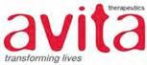

AVITA Therapeutics Provides Company Update

and Revised Corporate Presentation

Valencia, Calif., USA, and Melbourne, Australia, August 26, 2020 — AVITA Therapeutics, Inc. (NASDAQ: RCEL, ASX:AVH), a regenerative medicine company that is developing and commercializing a technology platform that enables point-of-care autologous skin restoration for multiple unmet needs, today provided an update on corporate developments.

- U.S. RECELL® System Sales:

  - July represented the highest monthly sales for RECELL Systems in the United States since launch in January 2019.

  - Unaudited sales for the RECELL System in July were U.S.$1.83 million.

  - July also witnessed very broad utilization of the RECELL System with 57 unique account orders, and more than 90 physicians using the RECELL System.

  - AVITA expects quarterly revenue in the September quarter to resume growth, and for sales to exceed the U.S.$3.9 million previously reported for the three (3) months ended June 30, 2020.

    - Recall that in the quarter ended June 30, 2020 revenue was deeply impacted by COVID in the United States with sales in the month of April down approximately 25% (versus the previous month).

    - Revenue then recovered in both May and June to deliver a flat sequential quarterly revenue result from the March quarter to the June quarter.

- Clinical Studies:

  - As previously advised, the U.S. Food & Drug Administration (FDA) granted an investigational device exemption (IDE) to support a vitiligo pivotal study on July 2nd, 2020.

  - Since receipt of the IDE, the Company has worked aggressively to obtain investigational review board approval (IRB) to support initiation of this study, together with commencing contracting discussions with potential clinical sites.

  - AVITA expects to treat our first vitiligo patient during September 2020.

  - There is a very high degree of both patient and clinical site enthusiasm in participating in our vitiligo pivotal study. Further, the Company continues to believe that the RECELL System is uniquely positioned to offer vitiligo patients a single curative therapy given that the RECELL System has been used to treat over 1,000 vitiligo patients internationally, and has been shown to provide patient benefits to vitiligo patients in eight (8) per-reviewed publications.

  - AVITA is also actively endeavoring to increase the number of clinical studies participating in each of our clinical studies. Additional clinical study sites have recently been added to both the pediatric scald and the soft tissue pivotal studies, and more sites are expected to be onboarded over the next few months.

Avita Therapeutics, Inc. (ARBN 641 288 155) c-Mertons Corporate Services P/L Level 7, 330 Collins Street, Melbourne, Vic 3000 Page 1

- Corporate:

  - The Company expects to release its Annual Report for the twelve (12) months ended June 30, 2020 on August 28th.

  - The Company will participate both in the Morgan Stanley Virtual 18th Annual Global Healthcare Conference and the Cantor Global Healthcare Conference which are both scheduled to take place in September.

  - A copy of the Company’s revised corporate presentation is available on the Company’s website and is attached to this presentation.

For more detailed information on the Company’s recent developments, please see our press release dated July 10, 2020 (which is available on both the Company’s and ASX’s website).

Authorized for release by the Chief Executive Officer of Avita Therapeutics, Inc.

# # #

ABOUT AVITA THERAPEUTICS, INC.

AVITA Therapeutics is a regenerative medicine company with a technology platform positioned to address unmet medical needs in burns, chronic wounds, and aesthetics indications. AVITA Therapeutics’ patented and proprietary collection and application technology provides innovative treatment solutions derived from the regenerative properties of a patient’s own skin. The medical devices work by preparing a RES® REGENERATIVE EPIDERMAL SUSPENSION, an autologous suspension comprised of the patient’s skin cells necessary to regenerate natural healthy epidermis. This autologous suspension is then sprayed onto the areas of the patient requiring treatment.

AVITA Therapeutics’ first U.S. product, the RECELL® System, was approved by the U.S. Food and Drug Administration (FDA) in September 2018. The RECELL System is indicated for use in the treatment of acute thermal burns in patients 18 years and older. The RECELL System is used to prepare Spray-On Skin™ Cells using a small amount of a patient’s own skin, providing a new way to treat severe burns, while significantly reducing the amount of donor skin required. The RECELL System is designed to be used at the point of care alone or in combination with autografts depending on the depth of the burn injury. Compelling data from randomized, controlled clinical trials conducted at major U.S. burn centers and real-world use in more than 8,000 patients globally, reinforce that the RECELL System is a significant advancement over the current standard of care for burn patients and offers benefits in clinical outcomes and cost savings. Healthcare professionals should read the INSTRUCTIONS FOR USE—RECELL® Autologous Cell Harvesting Device (https://recellsystem.com/) for a full description of indications for use and important safety information including contraindications, warnings and precautions.

In international markets, our products are marketed under the RECELL System brand to promote skin healing in a wide range of applications including burns, chronic wounds and aesthetics. The RECELL System is TGA-registered in Australia and received CE-mark approval in Europe.

To learn more, visit www.avitamedical.com.

CAUTIONARY NOTE REGARDING FORWARD-LOOKING STATEMENTS

This letter includes forward-looking statements. These forward-looking statements generally can be identified by the use of words such as “anticipate,” “expect,” “intend,” “could,” “may,” “will,” “believe,”

Avita Therapeutics, Inc. (ARBN 641 288 155) c-Mertons Corporate Services P/L Level 7, 330 Collins Street, Melbourne, Vic 3000 Page 2

“estimate,” “look forward,” “forecast,” “goal,” “target,” “project,” “continue,” “outlook,” “guidance,” “future,” other words of similar meaning and the use of future dates. Forward-looking statements in this letter include, but are not limited to, statements concerning, among other things, our ongoing clinical trials and product development activities, regulatory approval of our products, the potential for future growth in our business, and our ability to achieve our key strategic, operational and financial goal. Forward-looking statements by their nature address matters that are, to different degrees, uncertain. Each forward- looking statement contained in this letter is subject to risks and uncertainties that could cause actual results to differ materially from those expressed or implied by such statement. Applicable risks and uncertainties include, among others, the timing of regulatory approvals of our products; physician acceptance, endorsement, and use of our products; failure to achieve the anticipated benefits from approval of our products; the effect of regulatory actions; product liability claims; risks associated with international operations and expansion; and other business effects, including the effects of industry, economic or political conditions outside of the company’s control. Investors should not place considerable reliance on the forward-looking statements contained in this letter. Investors are encouraged to read our publicly available filings for a discussion of these and other risks and uncertainties. The forward-looking statements in this letter speak only as of the date of this release, and we undertake no obligation to update or revise any of these statements.

FOR FURTHER INFORMATION:
U.S. Media |  | Investors:
Sam Brown, Inc. |  | Westwicke Partners
Christy Curran |  | Caroline Corner
Phone +1 615 414 8668 |  | Phone +1 415 202 5678
christycurran@sambrown.com |  | caroline.corner@westwicke.com

O.U.S Media | AVITA Therapeutics, Inc.
Monsoon Communications | David McIntyre
Rudi Michelson | Chief Financial Officer Phone +1 661 367 9178
Phone +61 (0)3 9620 3333 | dmcintyre@avitamedical.com

Mobile +61 (0)411 402 737

rudim@monsoon.com.au

# # #

PR20200826

Avita Therapeutics, Inc. (ARBN 641 288 155) c-Mertons Corporate Services P/L Level 7, 330 Collins Street, Melbourne, Vic 3000 Page 3

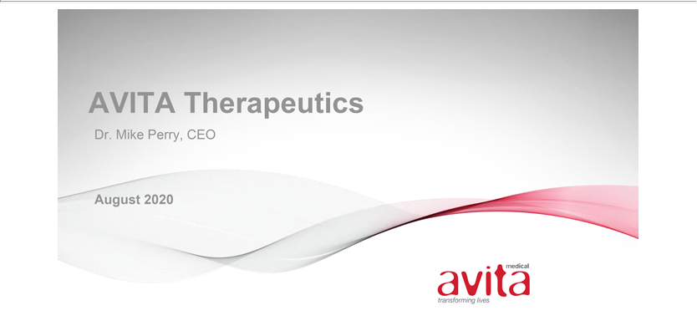

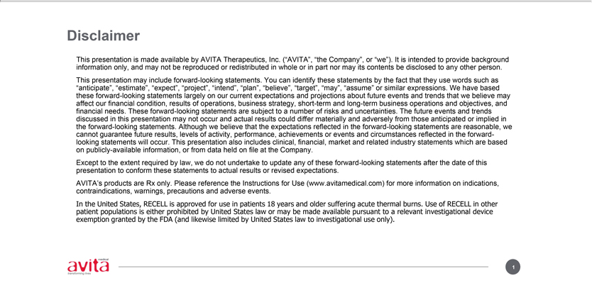

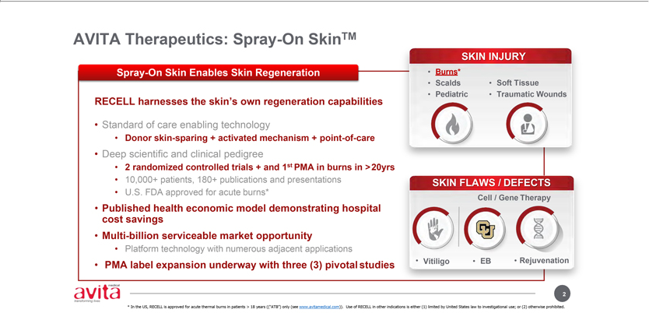

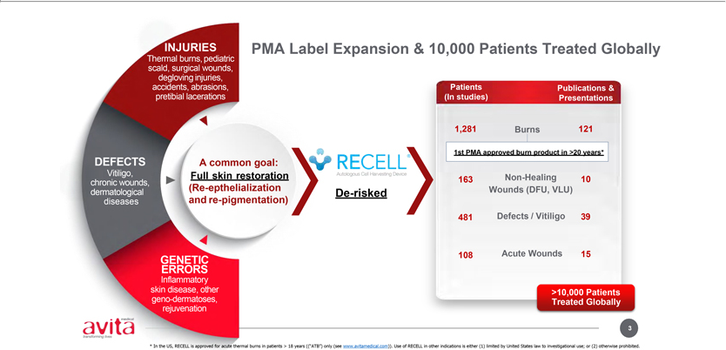

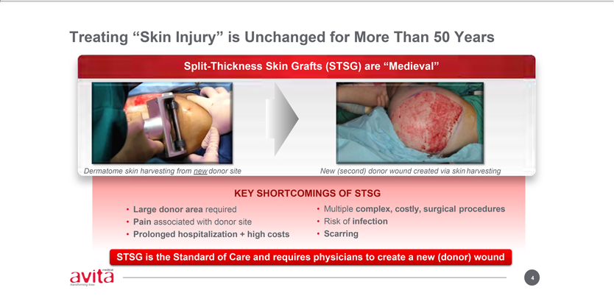

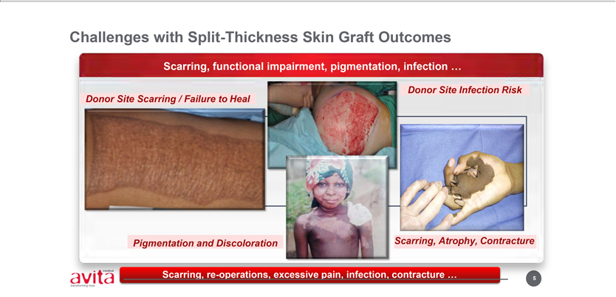

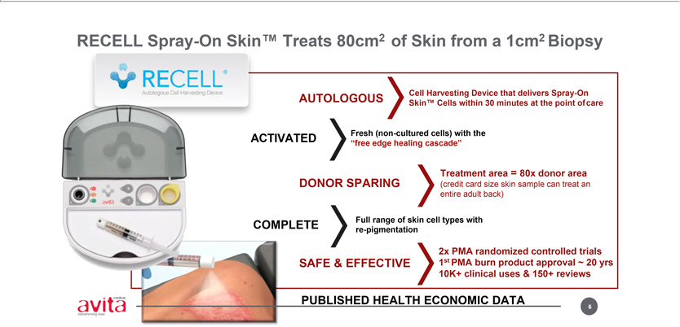

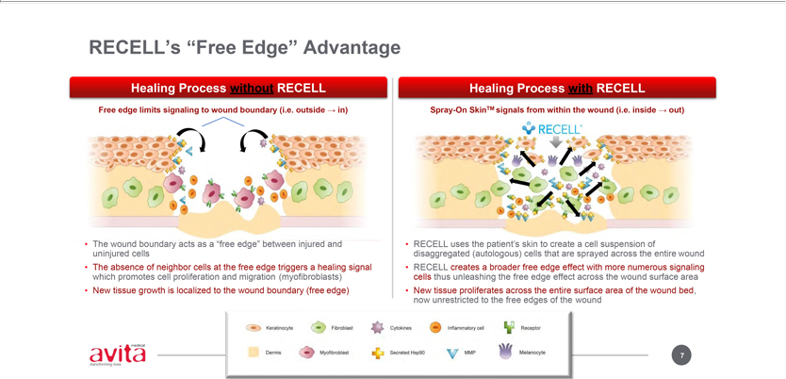

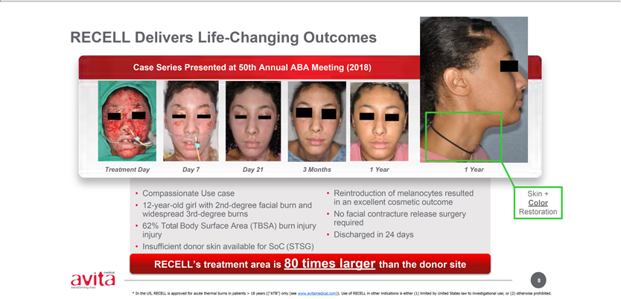

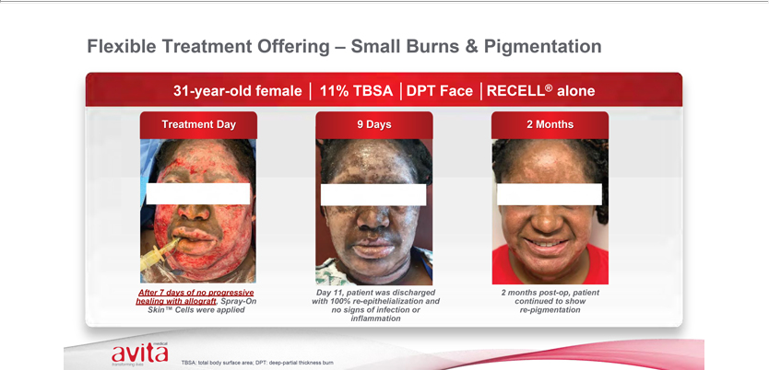

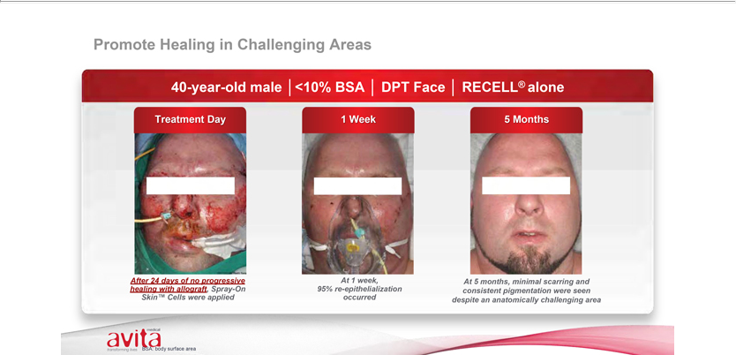

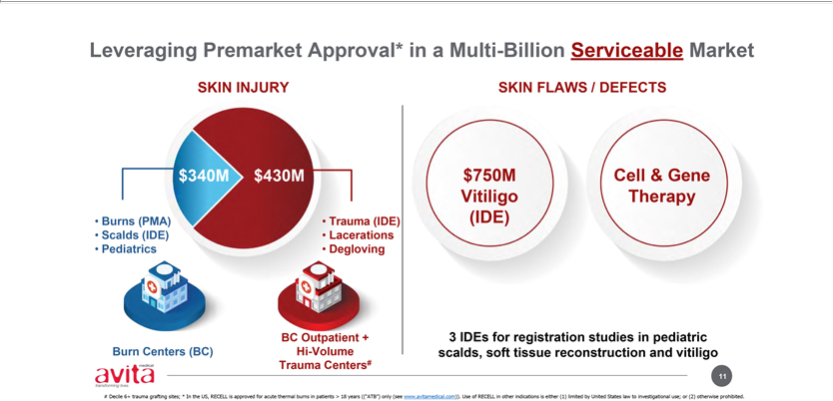

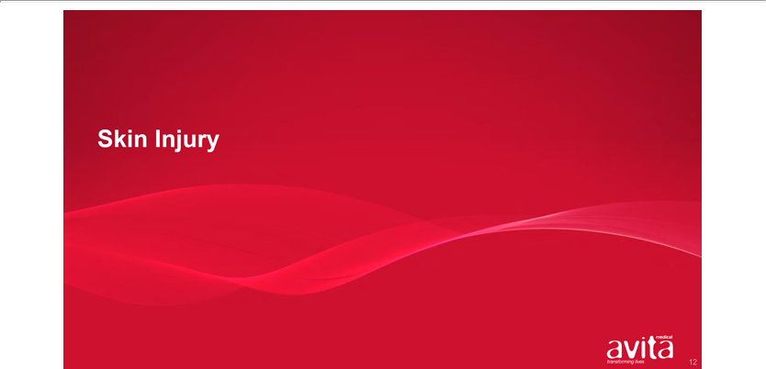

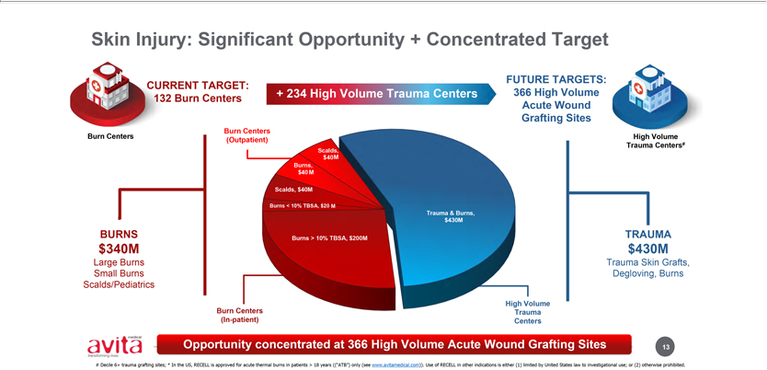

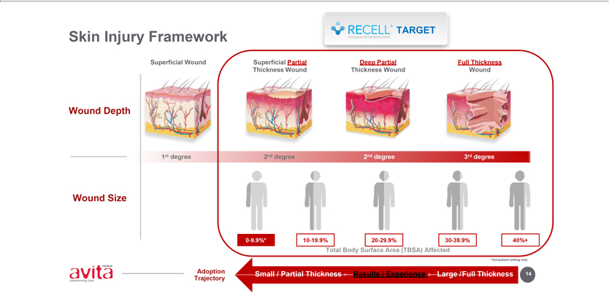

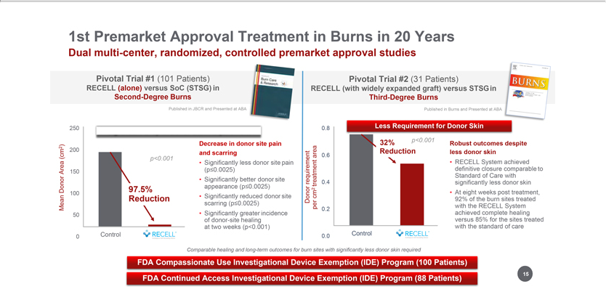

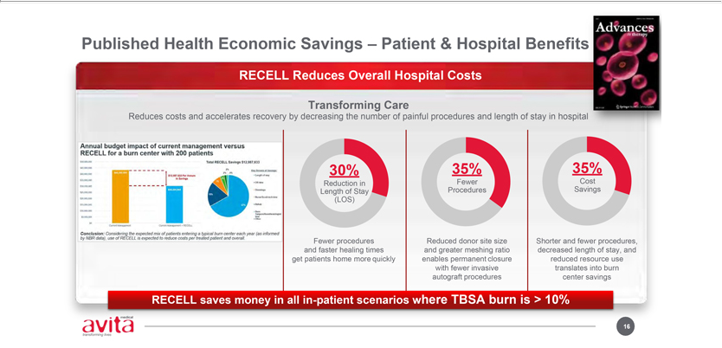

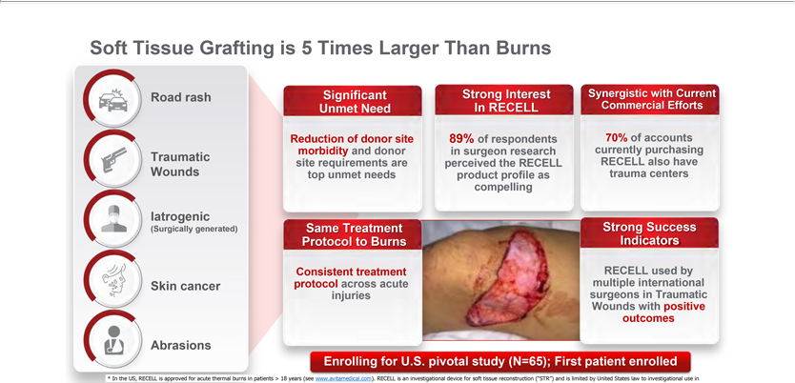

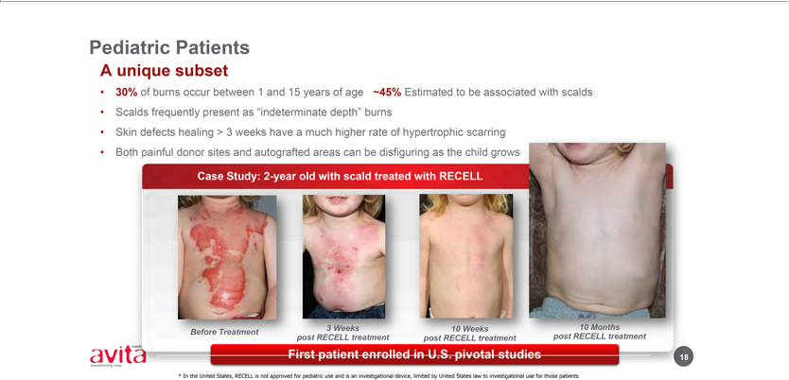

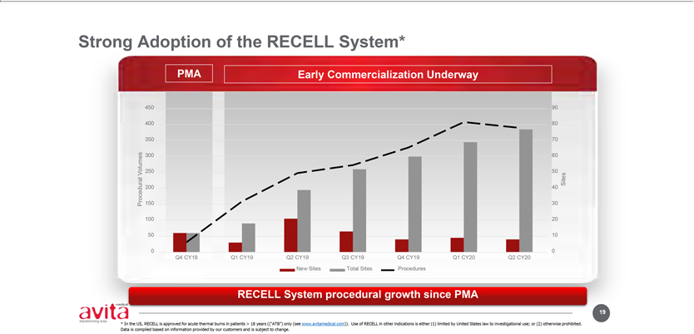

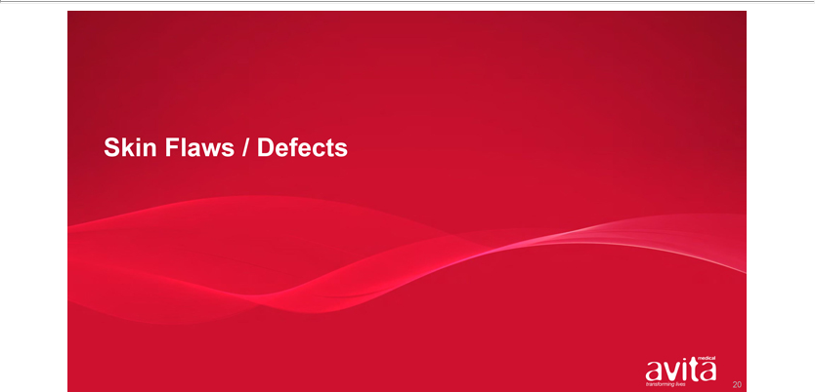

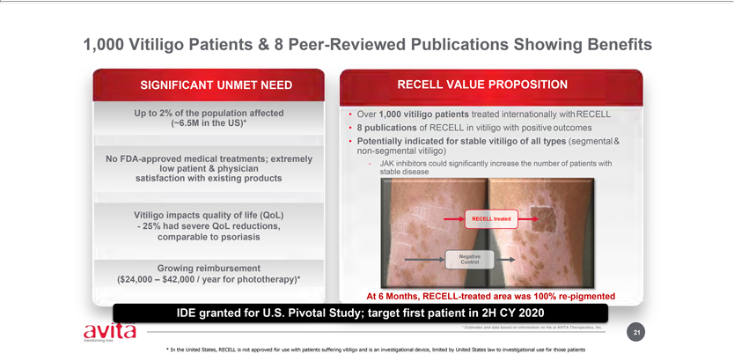

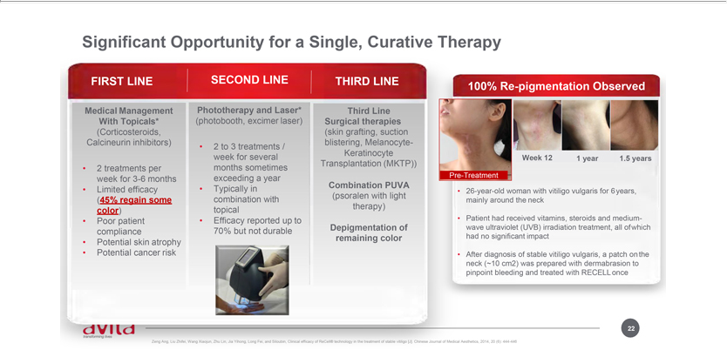

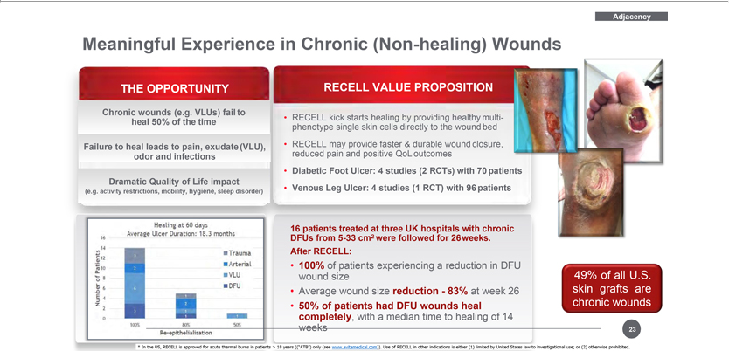

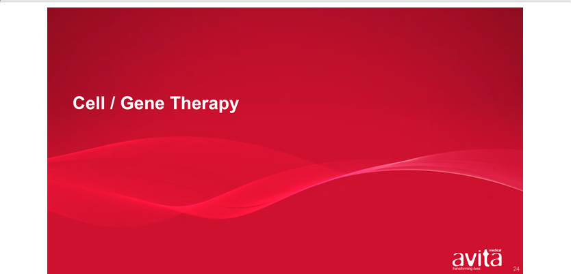

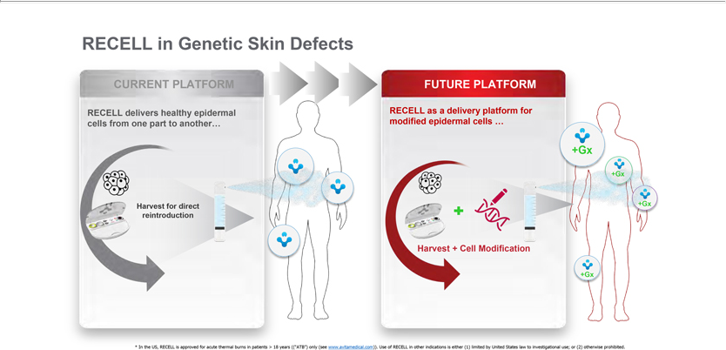

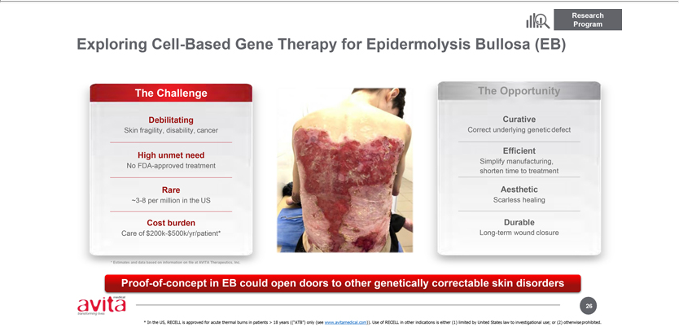

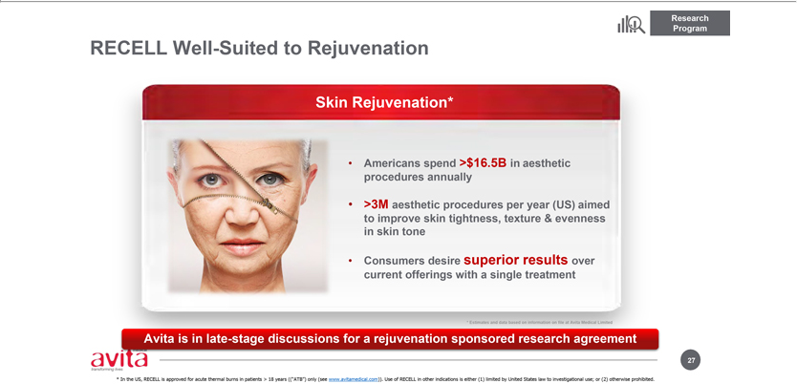

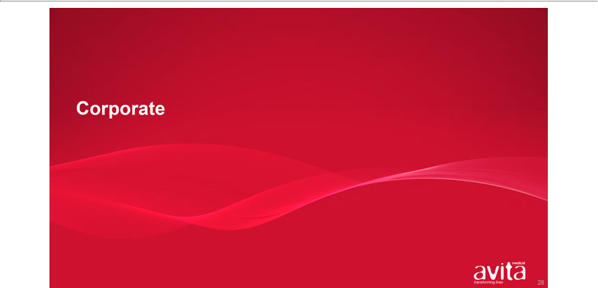

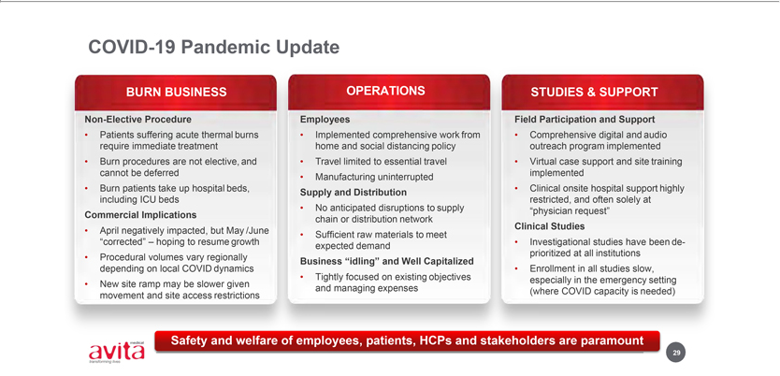

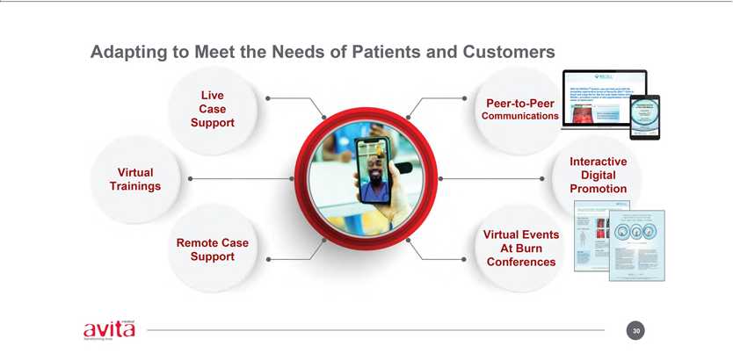

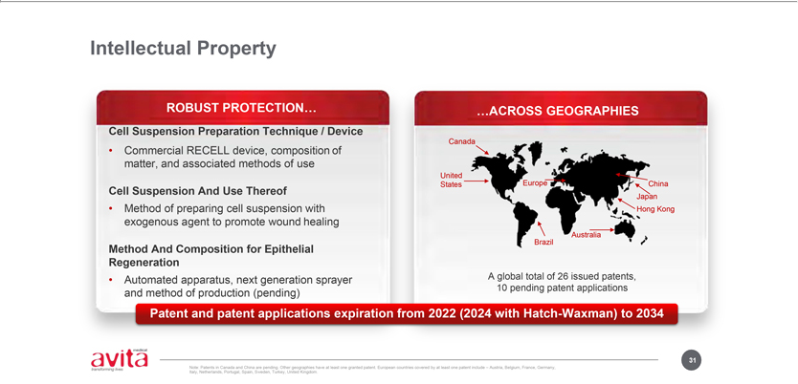

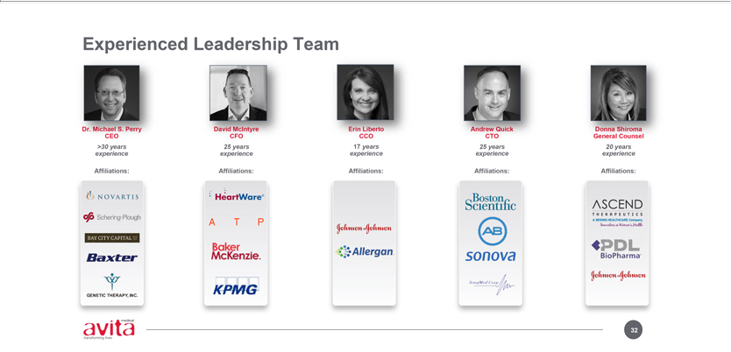

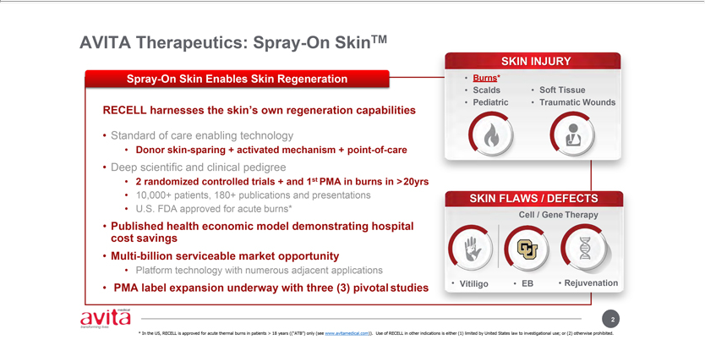

Exhibit 99.2


AVITA Therapeutics Provides Company Update and Revised Corporate Presentation

August 26, 2020

VALENCIA, Calif. & MELBOURNE, Australia—(BUSINESS WIRE)— Aug. 26, 2020— AVITA Therapeutics, Inc. (NASDAQ: RCEL, ASX: AVH), a regenerative medicine company that is developing and commercializing a technology platform that enables point-of-care autologous skin restoration for multiple unmet needs, today provided an update on corporate developments.

- U.S. RECELL® System Sales:

  - July represented the highest monthly sales for RECELL Systems in the United States since launch in January 2019.

  - Unaudited sales for the RECELL System in July were U.S.$1.83 million.

  - July also witnessed very broad utilization of the RECELL System with 57 unique account orders, and more than 90 physicians using the RECELL System.

  - AVITA expects quarterly revenue in the September quarter to resume growth, and for sales to exceed the U.S.$3.9 million previously reported for the three (3) months ended June 30, 2020.

    - Recall that in the quarter ended June 30, 2020 revenue was deeply impacted by COVID in the United States with sales in the month of April down approximately 25% (versus the previous month).

    - Revenue then recovered in both May and June to deliver a flat sequential quarterly revenue result from the March quarter to the June quarter.

- Clinical Studies:

  - As previously advised, the U.S. Food & Drug Administration (FDA) granted an investigational device exemption (IDE) to support a vitiligo pivotal study on July 2nd, 2020.

  - Since receipt of the IDE, the Company has worked aggressively to obtain investigational review board approval (IRB) to support initiation of this study, together with commencing contracting discussions with potential clinical sites.

  - AVITA expects to treat our first vitiligo patient during September 2020.

  - There is a very high degree of both patient and clinical site enthusiasm in participating in our vitiligo pivotal study. Further, the Company continues to believe that the RECELL System is uniquely positioned to offer vitiligo patients a single curative therapy given that the RECELL System has been used to treat over 1,000 vitiligo patients internationally, and has been shown to provide patient benefits to vitiligo patients in eight (8) peer-reviewed publications.

  - AVITA is also actively endeavoring to increase the number of clinical studies participating in each of our clinical studies. Additional clinical study sites have recently been added to both the pediatric scald and the soft tissue pivotal studies, and more sites are expected to be onboarded over the next few months.

- Corporate:

  - The Company expects to release its Annual Report for the twelve (12) months ended June 30, 2020 on August 28th.

  - The Company will participate both in the Morgan Stanley Virtual 18th Annual Global Healthcare Conference and the Cantor Global Healthcare Conference, which are both scheduled to take place in September.

  - A copy of the Company’s revised corporate presentation is available on the Company’s website.

For more detailed information on the Company’s recent developments, please see our press release dated July 10, 2020 (which is available on both the Company’s and ASX’s website).

Authorized for release by the Chief Executive Officer of AVITA Therapeutics, Inc.

ABOUT AVITA THERAPEUTICS, INC.

AVITA Therapeutics is a regenerative medicine company with a technology platform positioned to address unmet medical needs in burns, chronic wounds, and aesthetics indications. AVITA Therapeutics’ patented and proprietary collection and application technology provides innovative treatment solutions derived from the regenerative properties of a patient’s own skin. The medical devices work by preparing a RES ® REGENERATIVE EPIDERMAL SUSPENSION, an autologous suspension comprised of the patient’s skin cells necessary to regenerate natural healthy epidermis. This autologous suspension is then sprayed onto the areas of the patient requiring treatment.

AVITA Therapeutics’ first U.S. product, the RECELL® System, was approved by the U.S. Food and Drug Administration (FDA) in September 2018.

The RECELL System is indicated for use in the treatment of acute thermal burns in patients 18 years and older. The RECELL System is used to prepare

Spray-On Skin™ Cells using a small amount of a patient’s own skin, providing a new way to treat severe burns, while significantly reducing

the amount of donor skin required. The RECELL System is designed to be used at the point of care alone or in combination with autografts depending on the depth of the burn injury. Compelling data from randomized, controlled clinical trials conducted at major U.S. burn centers and real-world use in more than 8,000 patients globally, reinforce that the RECELL System is a significant advancement over the current standard of care for burn patients and offers benefits in clinical outcomes and cost savings. Healthcare professionals should read the INSTRUCTIONS FOR USE—RECELL® Autologous Cell Harvesting Device (https://recellsystem.com/) for a full description of indications for use and important safety information including contraindications, warnings and precautions.

In international markets, our products are marketed under the RECELL System brand to promote skin healing in a wide range of applications including burns, chronic wounds and aesthetics. The RECELL System is TGA-registered in Australia and received CE-mark approval in Europe.

To learn more, visit www.avitamedical.com.

CAUTIONARY NOTE REGARDING FORWARD-LOOKING STATEMENTS

This letter includes forward-looking statements. These forward-looking statements generally can be identified by the use of words such as “anticipate,” “expect,” “intend,” “could,” “may,” “will,” “believe,” “estimate,” “look forward,” “forecast,” “goal,” “target,” “project,” “continue,” “outlook,” “guidance,” “future,” other words of similar meaning and the use of future dates. Forward-looking statements in this letter include, but are not limited to, statements concerning, among other things, our ongoing clinical trials and product development activities, regulatory approval of our products, the potential for future growth in our business, and our ability to achieve our key strategic, operational and financial goal. Forward-looking statements by their nature address matters that are, to different degrees, uncertain. Each forward-looking statement contained in this letter is subject to risks and uncertainties that could cause actual results to differ materially from those expressed or implied by such statement. Applicable risks and uncertainties include, among others, the timing of regulatory approvals of our products; physician acceptance, endorsement, and use of our products; failure to achieve the anticipated benefits from approval of our products; the effect of regulatory actions; product liability claims; risks associated with international operations and expansion; and other business effects, including the effects of industry, economic or political conditions outside of the company’s control. Investors should not place considerable reliance on the forward-looking statements contained in this letter. Investors are encouraged to read our publicly available filings for a discussion of these and other risks and uncertainties. The forward-looking statements in this letter speak only as of the date of this release, and we undertake no obligation to update or revise any of these statements.

View source version on businesswire.com: https://www.businesswire.com/news/home/20200826005296/en/

U.S. Media

Sam Brown, Inc.

Christy Curran

Phone +1 615 414 8668

christycurran@sambrown.com

O.U.S Media

Monsoon Communications

Rudi Michelson

Phone +61 (0)3 9620 3333

Mobile +61 (0)411 402 737

rudim@monsoon.com.au

Investors:

Westwicke Partners

Caroline Corner

Phone +1 415 202 5678

caroline.corner@westwicke.com

AVITA Therapeutics, Inc.

David McIntyre

Chief Financial Officer

Phone +1 661 367 9178

dmcintyre@avitamedical.com

Source: AVITA Therapeutics, Inc.

