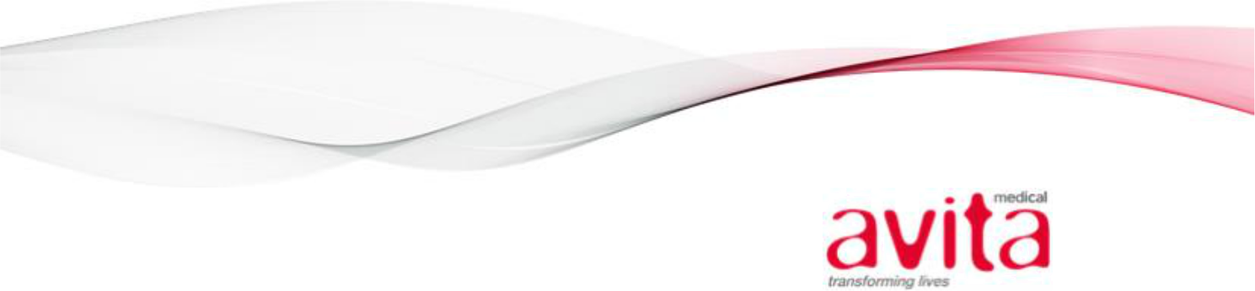

February 19, 2021

U.S. Securities and Exchange Commission (“Commission” or “Staff”)

Attn: Jenn Do and Vanessa Robertson

Division of Corporation Finance

Office of Life Sciences

Washington, DC 20549

Re: Avita Medical, Inc.

Form 10-K for the Fiscal Year ended June 30, 2020

Filed August 27, 2020

File No. 1-39059

Dear Ms. Do and Ms. Robertson:

Reference is made to the letter received from the Commission dated February 10, 2021 regarding the Form 10-K for the fiscal year ended June 30, 2020 (the “10-K”) of Avita Medical, Inc. (the “Company”).

For your convenience, we have included your comments in this response letter in bold form and keyed our response accordingly. The Company’s response to the comments is as follows.

Form 10-K for the fiscal year ended June 30, 2020

Item 9A. Controls and Procedures, page 49

Comment:

- Please amend the 10-K to revise Management’s Report on Internal Control over Financial Reporting to specifically state whether or not the internal control over financial reporting was effective as of June 30, 2020. Your current disclosure refers to disclosure controls and procedures, which is separately assessed under “Evaluation of Disclosure Controls and Procedures”. Include updated management certifications as required.

Response:

We acknowledge the comment of the Staff, change in terminology was an inadvertent administrative error. The Company will amend the 10-K to revise Management’s Report on Internal Control over Financial Reporting to specifically state that the internal control over financial reporting was effective as of June 30, 2020. We will also include updated management certifications.

Consolidated Statements of Operations, page F-4

Comment:

- Please tell us how your presentation of a separate line item for stock-based compensation complies with SAB Topic 14F.

Avita Medical, Inc.

28159 Avenue Stanford, Suite 220 Valencia, CA 91355

P +1 (661) 367-9170 | f +1 (661) 367-9180 | avitamedical.com

Page Two

Response:

The Company’s considerations for selected presentation of share-based compensation as its own line item are set forth below:

- Historical Presentation—The Company has historically presented share-based compensation expense as a separate line item in the consolidated statement of operations, including in 2020 Annual Reports on Form 10-K for twelve months ended June 30, 2020, 2019 and 2018 and in its Quarterly Report on Form 10-Q the three months ended September 30, 2020. Further, as a foreign filer, the Company presented share-based compensation as its own financial statement line-item in the Annual Report on Form 20-F for the year ended June 30, 2019, which was filed with the Securities and Exchange Commission on October 31, 2019. As part of the redomiciliation the Company obtained relief from ASIC filing requirements. Given the large investor base, the Company strived to have a filing that meet the needs of the Australian investors while maintaining compliance with US GAAP and SEC filing requirements.

- Needs of financial statement users concerning the disclosure of total share-based compensation expense – Given the growth stage of the Company, including early commercialization with historical net operating losses, management determined that the users of the financial statements (investors and financial analysts) are primarily concerned with the Company’s revenue growth, the Company’s future pipeline and the cash burn rate. As such, given the significance of the share-based compensation expense in relation to other operating expenses, the Company determined that separate classification in its own line item would be more meaningful to the users of the financial statements.

- Classification – In evaluating the grants and the related expense, the awards are primarily related to the CEO and other executive officers. Compensation related to the executive positions is primarily presented in general and administrative expenses. Although this point is not explicitly stated in the financial statements, it can be obtained through a combination of information in our 10-K (Item 8 Financial Statements and Supplementary Data, Item 11 Executive Compensation, and Item 12 Security Ownership of Certain Beneficial Owners and Management and Related Stockholder Matters) along with information disclosed in Form 3 and Form 4 filings.

Materiality Assessment

We considered whether the departure from the presentation promulgated by SAB Topic 14F resulted in a material misstatement in the Company’s previously issued consolidated financial statements. In making our assessment, we considered the qualitative factors in SAB 99 concerning whether a misstatement could be material by a user of the financial statements. Specifically, we evaluated whether the presentation of share-based compensation on its own line in the Consolidated Statement of Operations could have impacted the achievement of bonus targets or market guidance, or on the Company’s compliance with loan covenants or other contractual requirements. Based on our qualitative assessment, we did not identify factors which would lead management to conclude that the departure from the presentation required by SAB Topic 14F resulted in a material misstatement of the Company’s previously issued financial statements.

The Company believes it is acceptable to conform the presentation of share-based compensation expense to the SAB Topic 14F guidance in its prospective period SEC filings beginning with Quarterly Report on Form 10-Q for the quarter ended December 31, 2020. Prior period presentation of the Statement of Operations will be updated to conform to the current period presentation, and disclosure will be added to Note 2 of the financial statements which highlights the reclassification of prior year amounts along with adding a table so that the readers of the financial statements can identify the impact of share-based compensation on each line of its Consolidated Statement of Operations. The Company has properly disclosed such reclassification of previously reported amounts in the second quarter ended December 31, 2020.

Avita Medical, Inc.

28159 Avenue Stanford, Suite 220 Valencia, CA 91355

P +1 (661) 367-9170 | f +1 (661) 367-9180 | avitamedical.com

Page Three

Should you have any questions or wish to discuss the foregoing in further detail, please feel free to contact us.

Sincerely,

Avita Medical Limited

By /s/ Sean Ekins

Sean Ekins, Interim Principal Financial and

Accounting Officer

Avita Medical, Inc.

28159 Avenue Stanford, Suite 220 Valencia, CA 91355

P +1 (661) 367-9170 | f +1 (661) 367-9180 | avitamedical.com

