UNITED STATES

SECURITIES AND EXCHANGE COMMISSION

Washington, D.C. 20549

FORM 8-K

CURRENT REPORT

Pursuant to Section 13 or 15(d)

of the Securities Exchange Act of 1934

Date of Report (Date of earliest event reported): December 12, 2022

Avita Medical, Inc.

(Exact name of registrant as specified in its charter)

Delaware

001-39059

85-1021707

(State or other jurisdiction

of incorporation)

(Commission

File Number)

(IRS Employer
Identification No.)

28159 Avenue Stanford, Suite 220, Valencia, CA 91355

661.367.9170

(Address of principal executive offices, including Zip Code)

(Registrant’s telephone number, including area code)

N/A

(Former name or former address, if changed since last report)

Check the appropriate box below if the Form 8-K filing is intended to simultaneously satisfy the filing obligation of the registrant under any of the following provisions:

- Written communications pursuant to Rule 425 under the Securities Act (17 CFR 230.425)

- Soliciting material pursuant to Rule 14a-12 under the Exchange Act (17 CFR 240.14a-12)

- Pre-commencement communications pursuant to Rule 14d-2(b) under the Exchange Act (17 CFR 240.14d-2(b))

- Pre-commencement communications pursuant to Rule 13e-4(c) under the Exchange Act (17 CFR 240.13e-4(c))

Securities registered pursuant to Section 12(b) of the Act:

 |  | Trading |  | Name of each exchange
Title of each class |  | Symbol(s) |  | on which registered
Common Stock, par value $0.0001 per share |  | RCEL |  | The Nasdaq Stock Market LLC

Indicate by check mark whether the registrant is an emerging growth company as defined in Rule 405 of the Securities Act of 1933 or Rule 12b-2 of the Securities Exchange Act of 1934. Emerging growth company ☒

If an emerging growth company, indicate by check mark if the registrant has elected not to use the extended transition period for complying with any new or revised financial accounting standards provided pursuant to Section 13(a) of the Exchange Act. ☐

Item 5.07. Submission of Matters to a Vote of Security Holders.

AVITA Medical, Inc. ( “Company”) held its 2022 Annual Meeting of Stockholders (“Annual Meeting”) virtually on December 12, 2022 (United States) (being December 13, 2022 in Australia). At the Annual Meeting, the total number of shares of common stock eligible to vote as of the record date, October 19, 2022 (Pacific Time), was 25,030,902 and, pursuant to the Company’s Amended and Restated Bylaws, majority shares were required to be present or represented at the Annual Meeting to constitute a quorum. The total number of shares of common stock present or represented at the Annual Meeting was 12,913,899, and a quorum therefore existed.

At the Annual Meeting:

- Election of Directors. All five directors named in the Company’s Proxy Statement for the Annual Meeting (“Proxy Statement”) were elected to serve on the Company’s Board of Directors with the following vote:

Name |  | Votes For | Votes Withheld |  |  | Non-Votes
Louis Panaccio (Chair) |  | 9,299,761 |  | 1,685,226 |  | 1,928,912
James Corbett (Executive Director and CEO) |  | 10,360,740 | 624,247 |  |  | 1,928,912
Jeremy Curnock Cook (Director) |  | 9,803,894 | 1,181,093 |  |  | 1,928,912
Professor Suzanne Crowe (Director) |  | 9,216,541 | 1,768,446 |  |  | 1,928,912
Jan Stern Reed (Director) |  | 9,926,444 | 1,058,543 |  |  | 1,928,912

- Appointment of Independent Auditors. The appointment of Grant Thornton LLP as the Company’s independent public accountants for the fiscal year ending December 31, 2022, was ratified by a vote of (i) 12,430,789 in favor, (ii) 224,743 against, and (iii) 258,367 abstaining.

- Amendments to the Company’s Amended and Restated Bylaws: Shareholders did not approve amendments to the Company’s Certificate of Incorporation and Amended and Restated Bylaws to reduce the quorum requirement for stockholder meetings, on the terms and conditions set out in the Proxy Statement, by a vote of (i) 9,587,285 in favor, (ii) 956,344 against, and (iii) 441,358 abstaining. Proposal 3 was not carried as the number of votes required to approve the proposal was not reached.

- Issuance of Securities to Mr. Louis Panaccio: Shareholders approved the grant of restricted stock units to acquire shares of common stock of the Company (which may be represented by CDIs) equal in value to US$87,500 (at the time of the grant) and the grant of options to acquire shares of common stock of the Company (which may be represented by CDIs) equal in value to US$37,500 (at the time of the grant) to Mr. Louis Panaccio on the terms and conditions set out in this Proxy Statement, pursuant to and for the purposes of ASX Listing Rule 10.11, by a vote of (i) 7,637,405 in favor, (ii) 2,735,159 against, and (iii) 612,423 abstaining.

- Issuance of Securities to Professor Suzanne Crowe: Shareholders approved the grant of restricted stock units to acquire shares of common stock of the Company (which may be represented by CDIs) equal in value to US$87,500 (at the time of the grant) and the grant of options to acquire shares of common stock of the Company (which may be represented by CDIs) equal in value to US$37,500 (at the time of the grant) to Professor Suzanne Crowe on the terms and conditions set out in this Proxy Statement, pursuant to and for the purposes of ASX Listing Rule 10.11, by a vote of (i) 7,656,800 in favor, (ii) 2,666,551 against, and (iii) 661,636 abstaining.

- Issuance of Securities to Mr. Jeremy Curnock Cook: Shareholders approved the grant of restricted stock units to acquire shares of common stock of the Company (which may be represented by CDIs) equal in value to US$87,500 (at the time of the grant) and the grant of options to acquire shares of common stock of the Company (which may be represented by CDIs) equal in value to US$37,500 (at the time of the grant) to

Mr. Jeremy Curnock Cook on the terms and conditions set out in this Proxy Statement, pursuant to and for the purposes of ASX Listing Rule 10.11, by a vote of (i) 7,612,792 in favor, (ii) 2,745,543 against, and (iii) 626,652 abstaining.

- Issuance of Securities to Ms. Jan Stern Reed: Shareholders approved the grant of restricted stock units to acquire shares of common stock of the Company (which may be represented by CDIs) equal in value to US$87,500 (at the time of the grant) and the grant of options to acquire shares of common stock of the Company (which may be represented by CDIs) equal in value to US$37,500 (at the time of the grant) to Ms. Jan Stern Reed on the terms and conditions set out in this Proxy Statement, pursuant to and for the purposes of ASX Listing Rule 10.11, by a vote of (i) 7,657,643 in favor, (ii) 2,674,563 against, and (iii) 652,781 abstaining.

- Issuance of Securities to Mr. James Corbett: Shareholders approved the grant of options to acquire shares of common stock of the Company (which may be represented by CDIs) equal in value to US$1,000,000 (at the time of the grant) to Mr. James Corbett on the terms and conditions set out in this Proxy Statement, pursuant to and for the purposes of ASX Listing Rule 10.11, by a vote of (i) 8,476,617 in favor, (ii) 1,869,887 against, and (iii) 638,483 abstaining.

- Advisory Vote to Approve Compensation of Named Executive Officers: Shareholders voted in favor of the non-binding advisory vote to approve the compensation of the Company’s named executive officers, by a vote of (i) 7,832,181 in favor, (ii) 2,381,954 against, and (iii) 770,852 abstaining.

Item 7.01 Reg Fd Disclosure; Item 8.01 Other Events

At the Annual Meeting, the Company presented a slide deck containing certain information attached hereto as Exhibit 99.1. Following the Annual Meeting, the Company issued a press release announcing the voting results with respect to each of the proposals presented to stockholders at the Annual Meeting. A copy of the Company’s press release is included as Exhibit 99.2.

The information under Item 5.07, Item 7.01, Item 8.01, and in Item 9.01 below is being furnished and shall not be deemed to be “filed” for purposes of Section 18 of the Securities Exchange Act of 1934 and shall not be deemed incorporated by reference into any filing made under the Securities Act of 1933, except as expressly set forth by specific reference in such filing.

Item 9.01 Financial Statements and Exhibits.

(d) Exhibits

Exhibit
No. |  | Description of Exhibit
99.1 |  | Annual Meeting Presentation.
99.2 |  | AVITA Medical Announces Results of 2022 Annual Meeting of Stockholders.
104 |  | Cover Page Interactive Data File (embedded within the Inline XBRL document).

SIGNATURE

Pursuant to the requirements of the Securities Exchange Act of 1934, the registrant has duly caused this report to be signed on its behalf by the undersigned hereunto duly authorized.

Date: December 14, 2022

AVITA MEDICAL, INC.

By: /s/ Donna Shiroma

Name: Donna Shiroma

Title: General Counsel

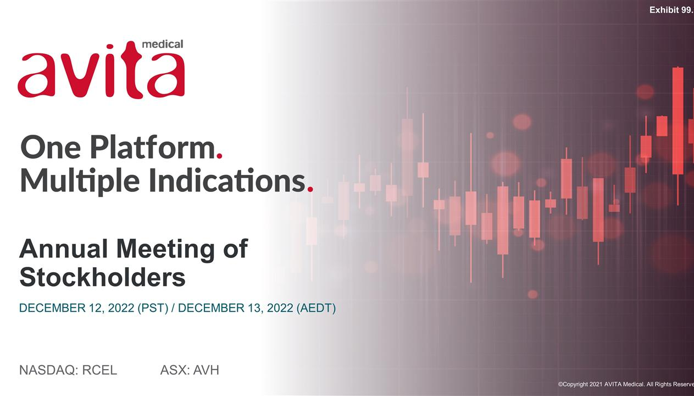

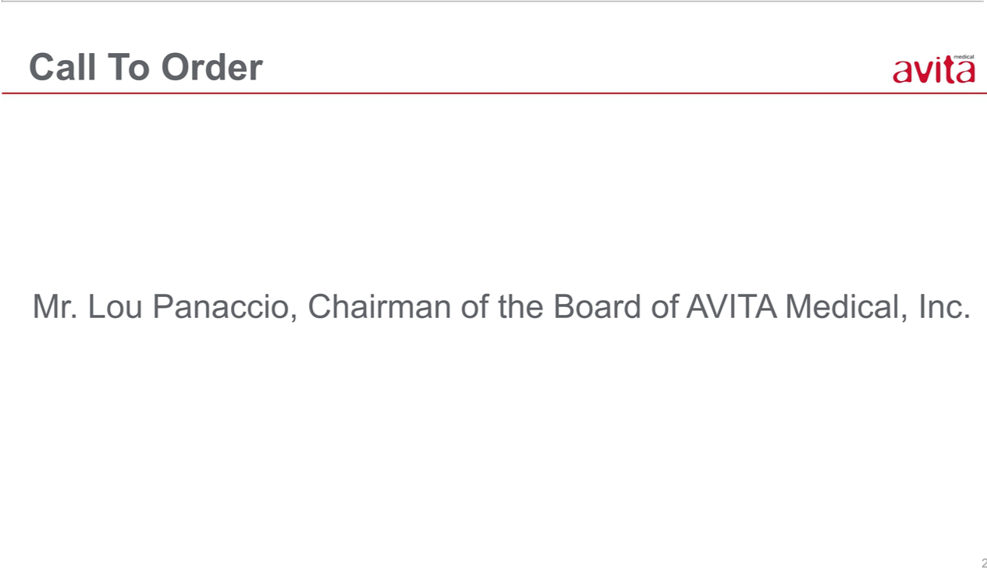

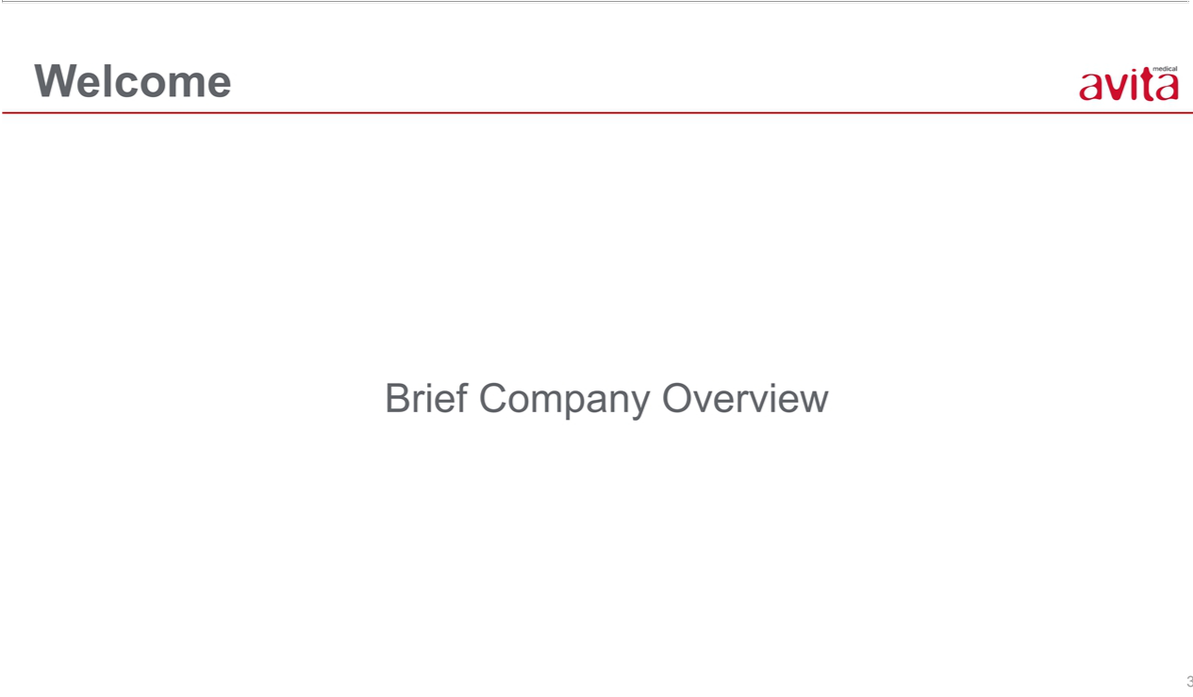

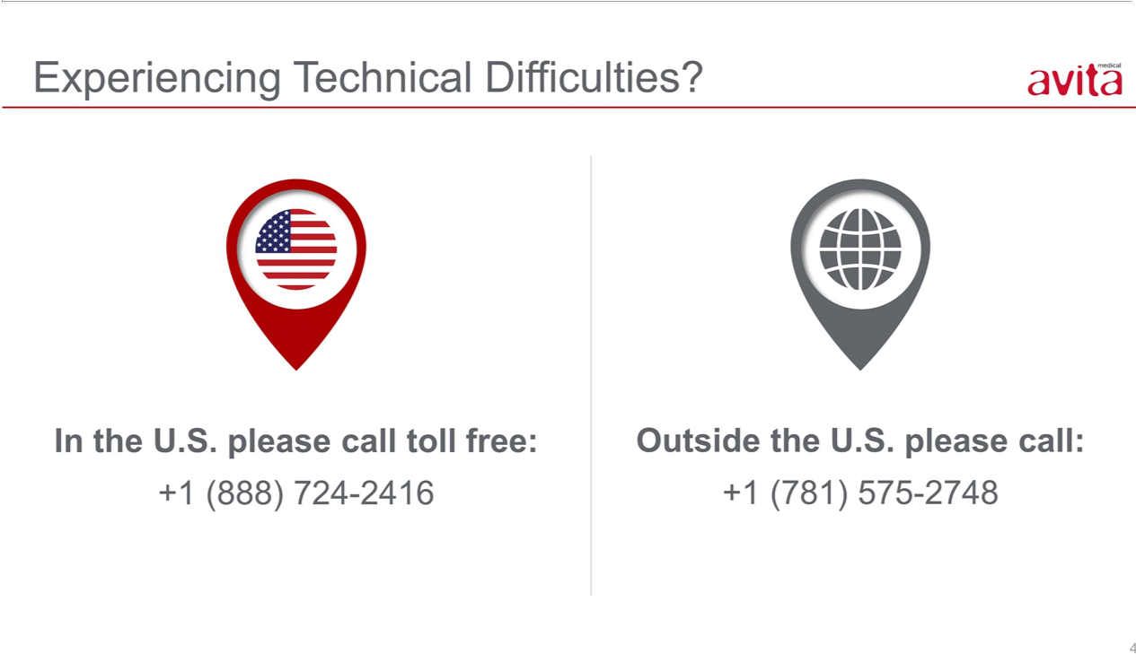

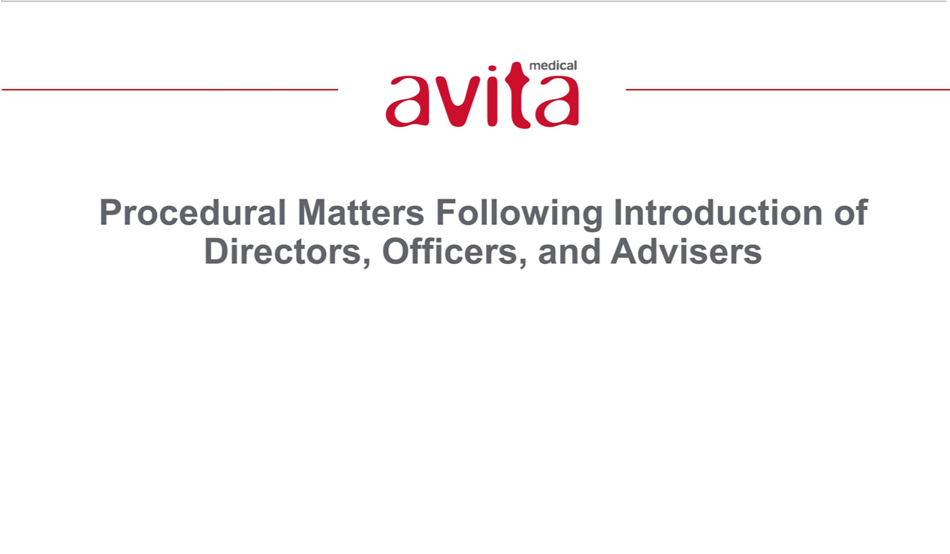

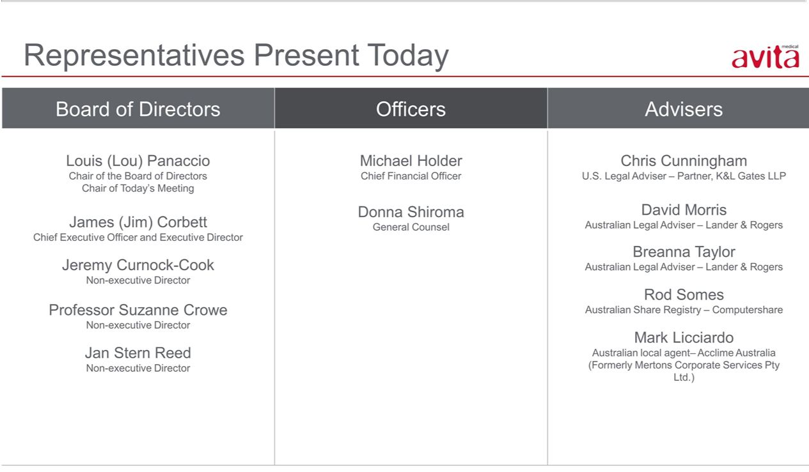

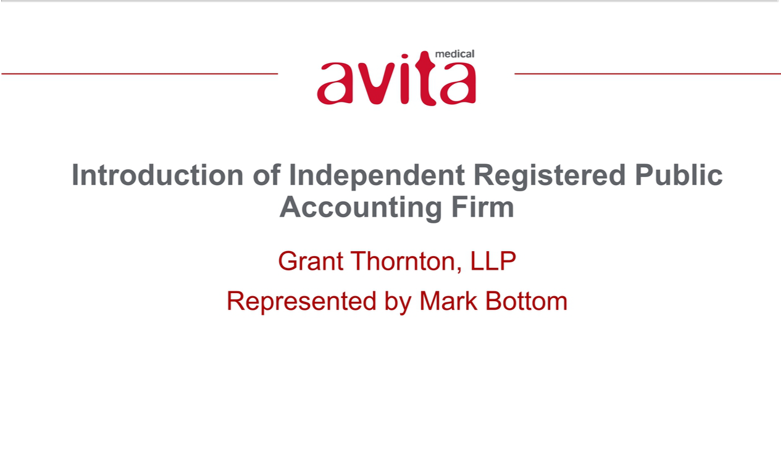

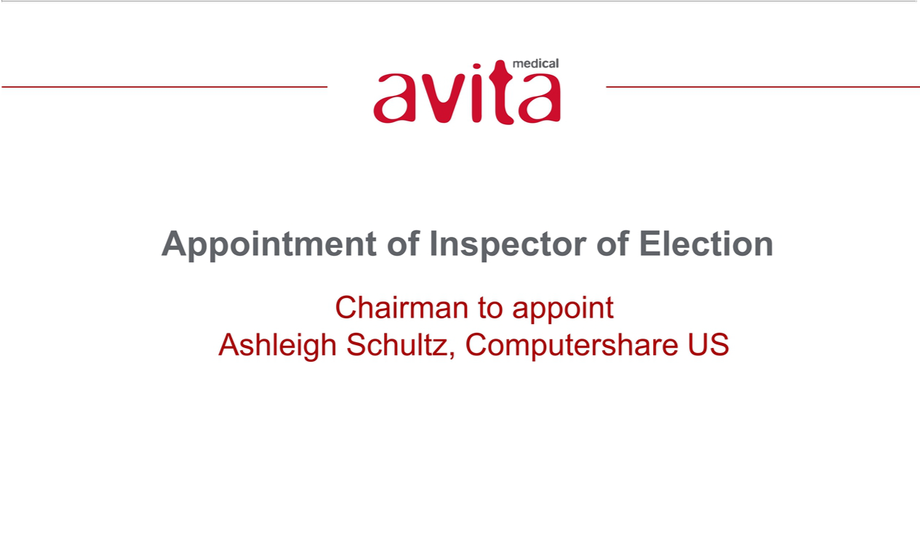

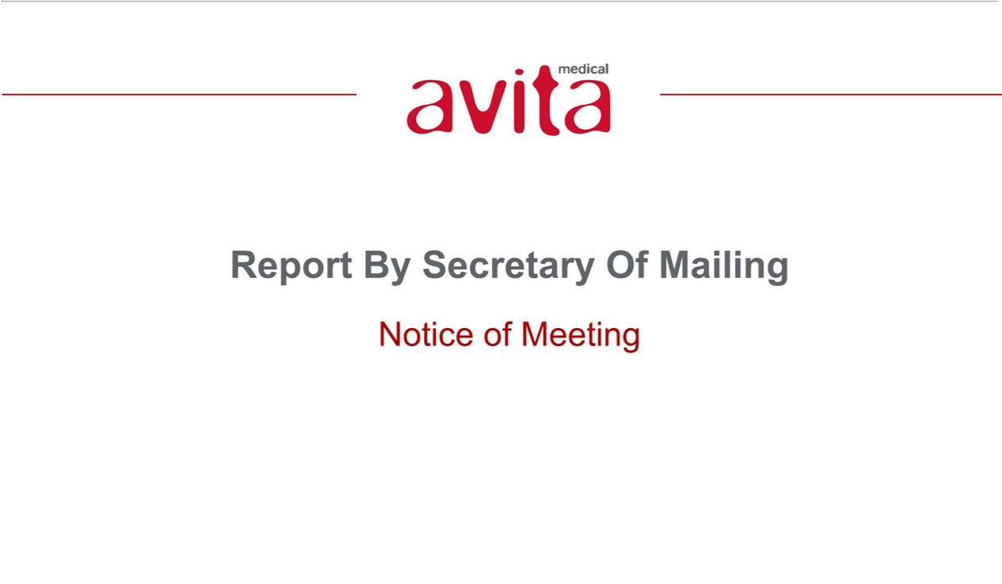

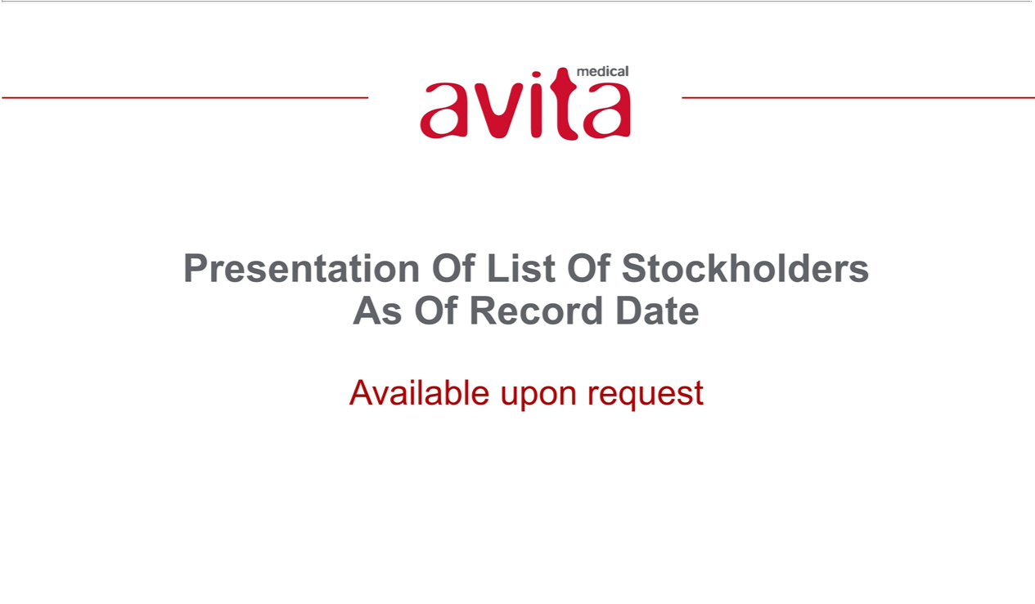

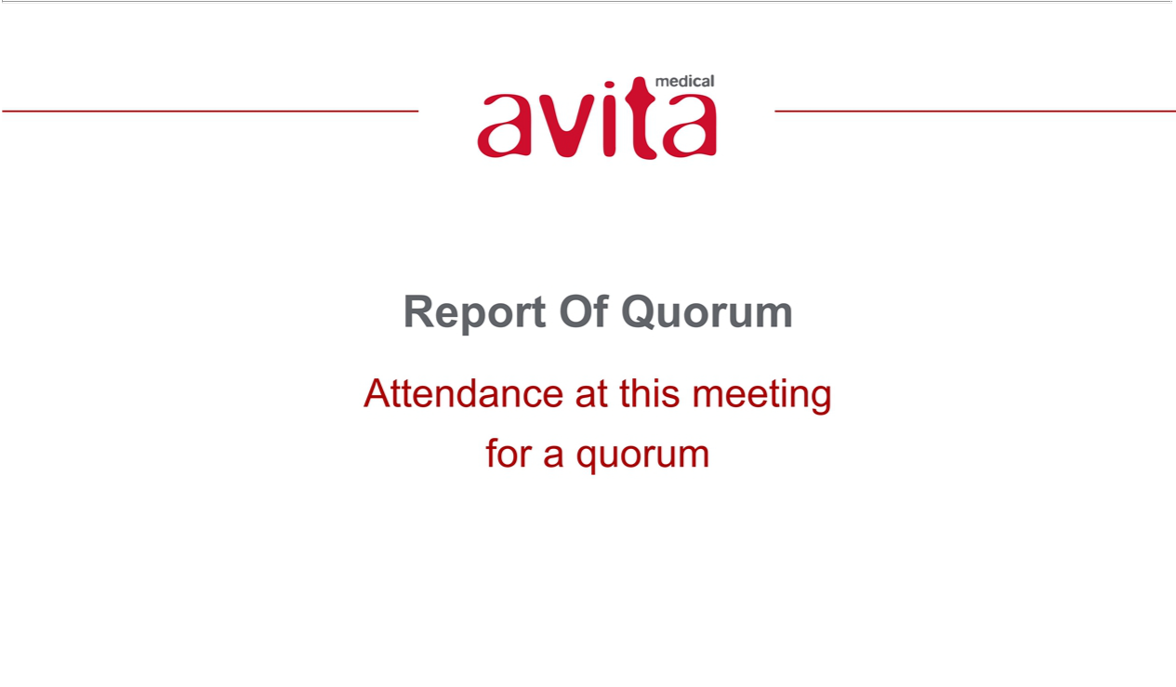

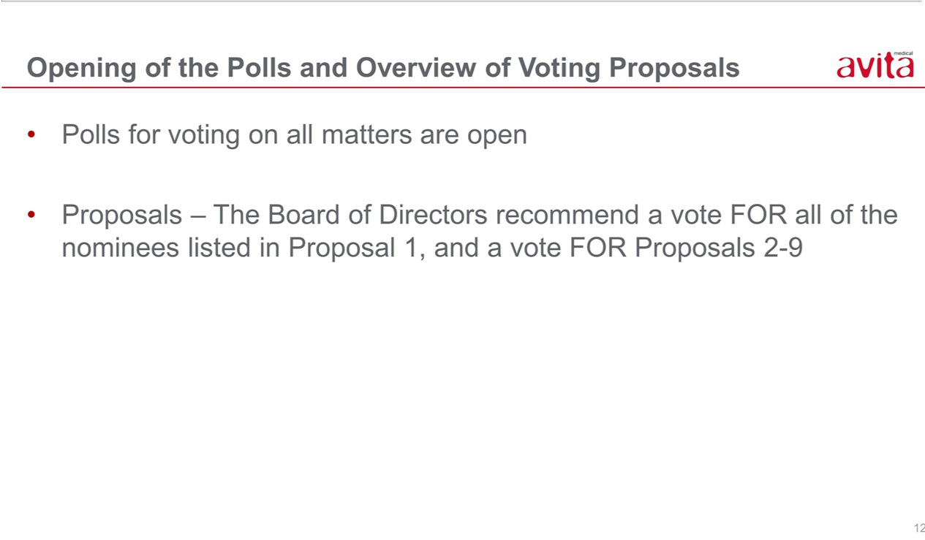

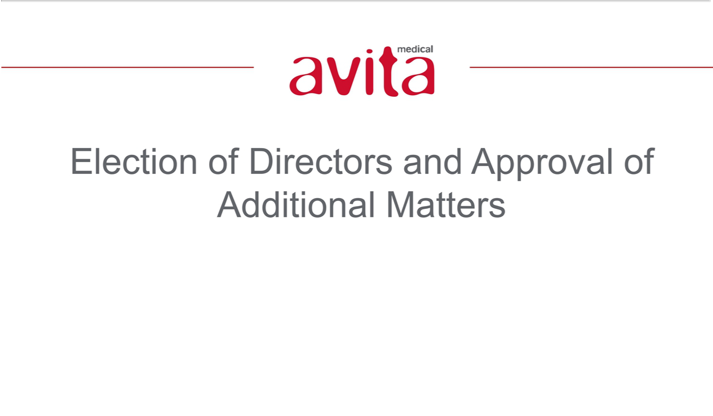

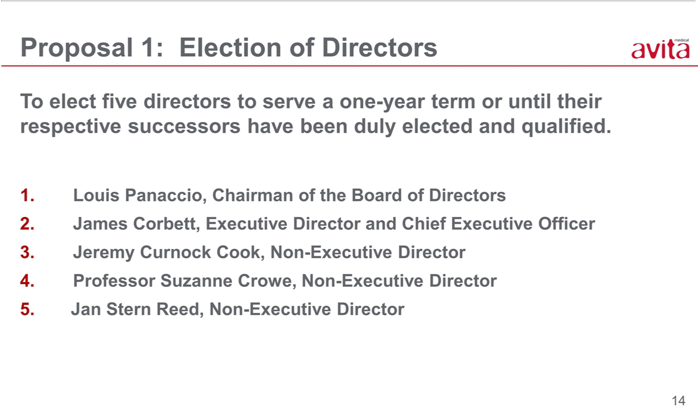

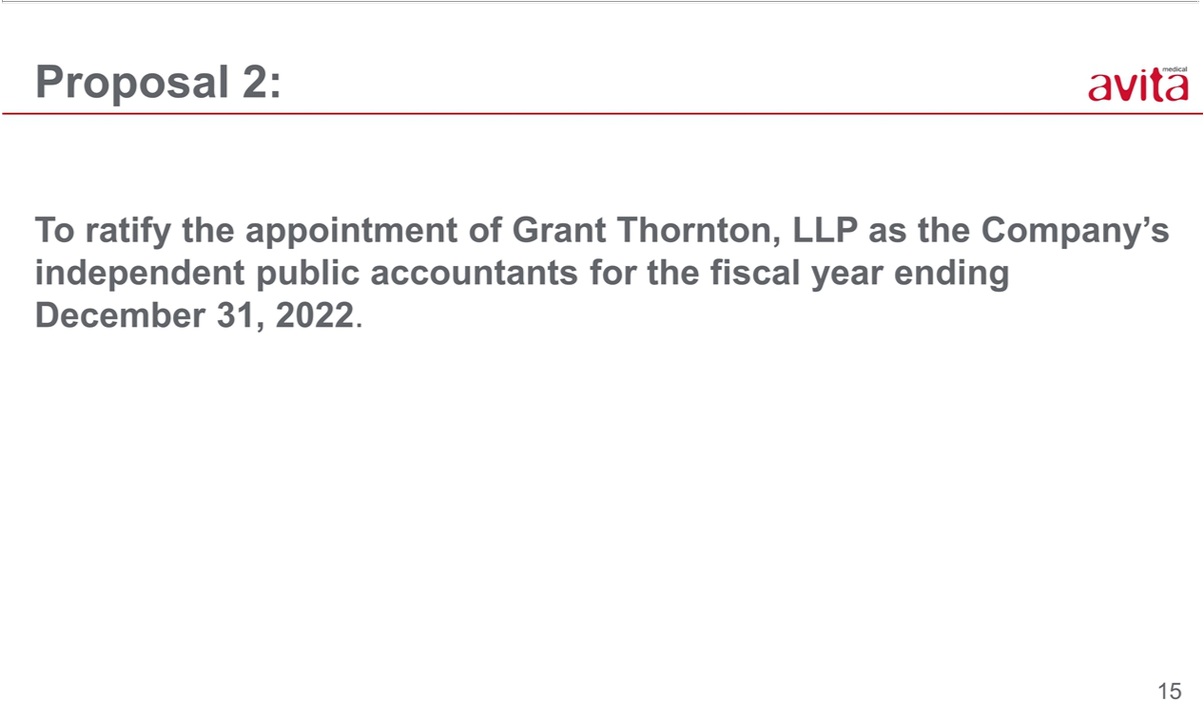

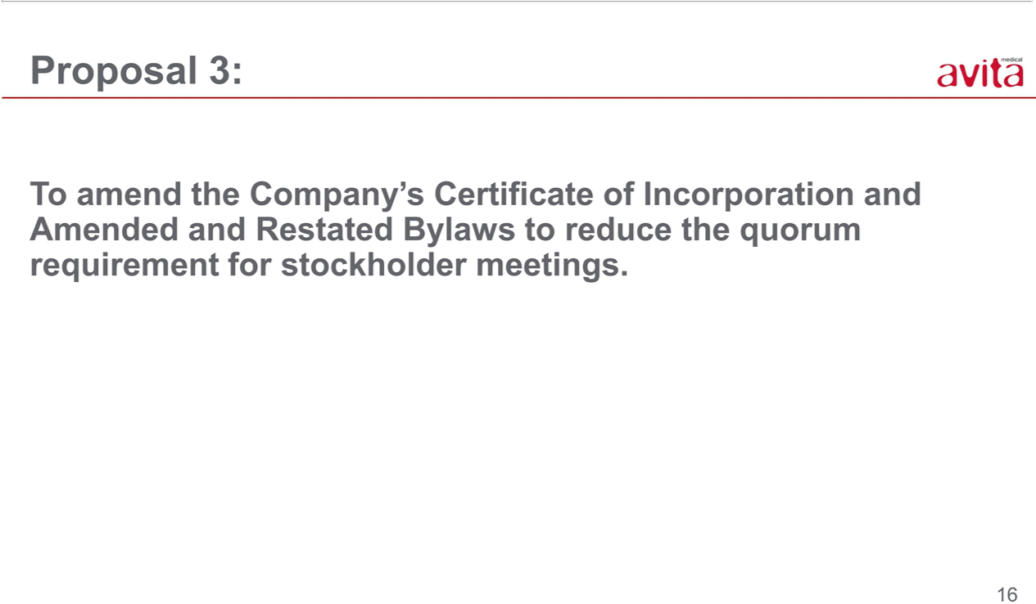

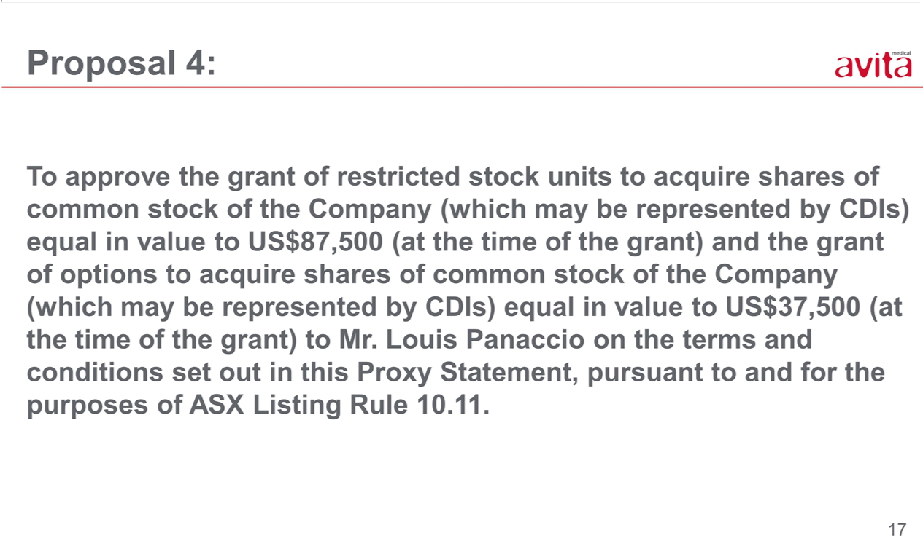

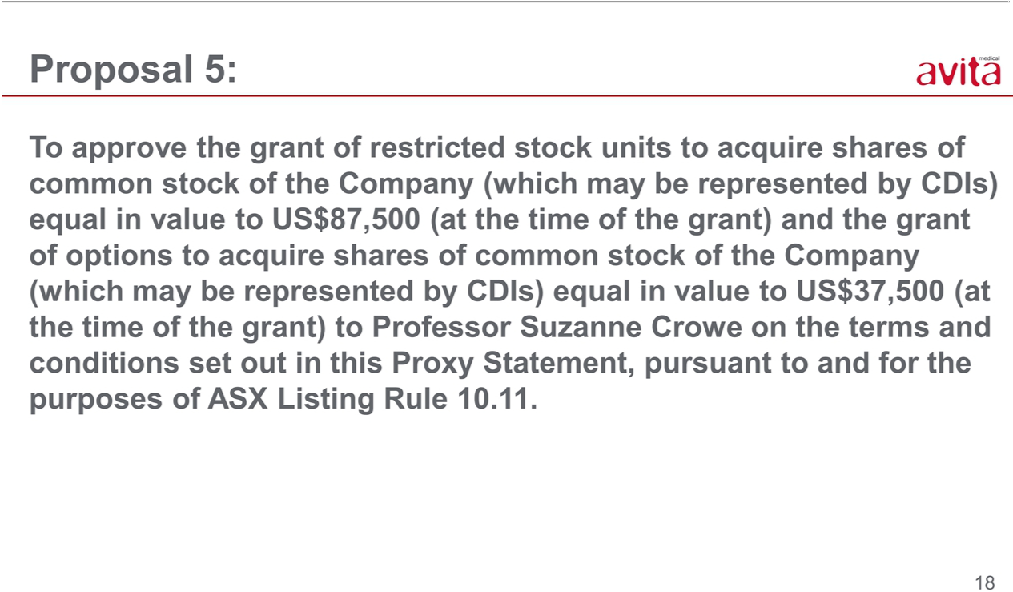

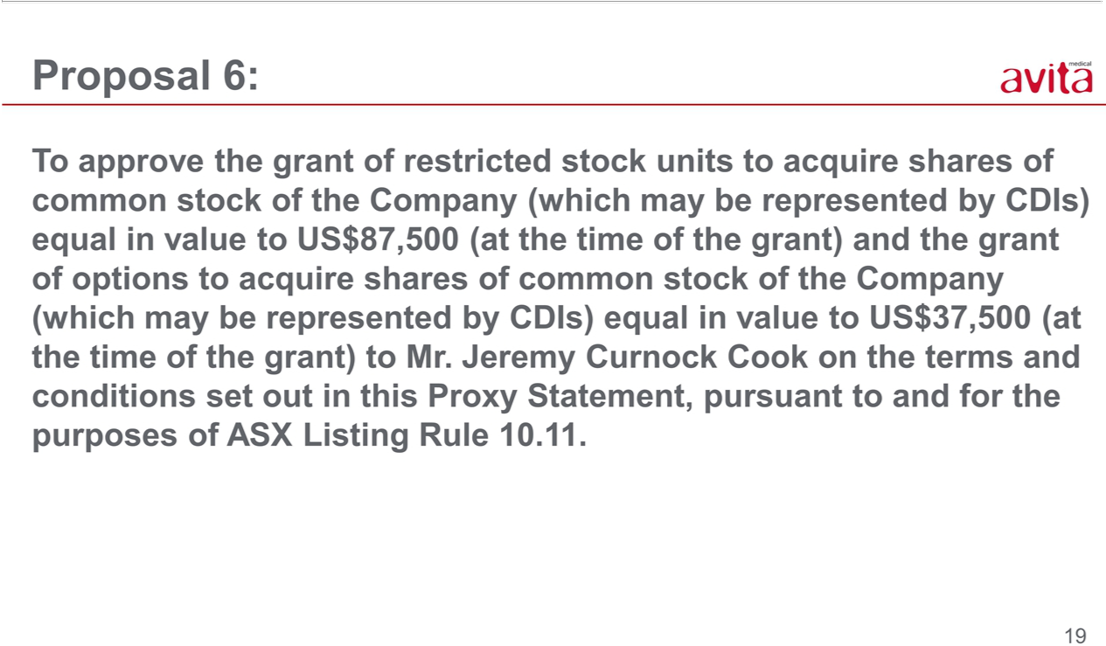

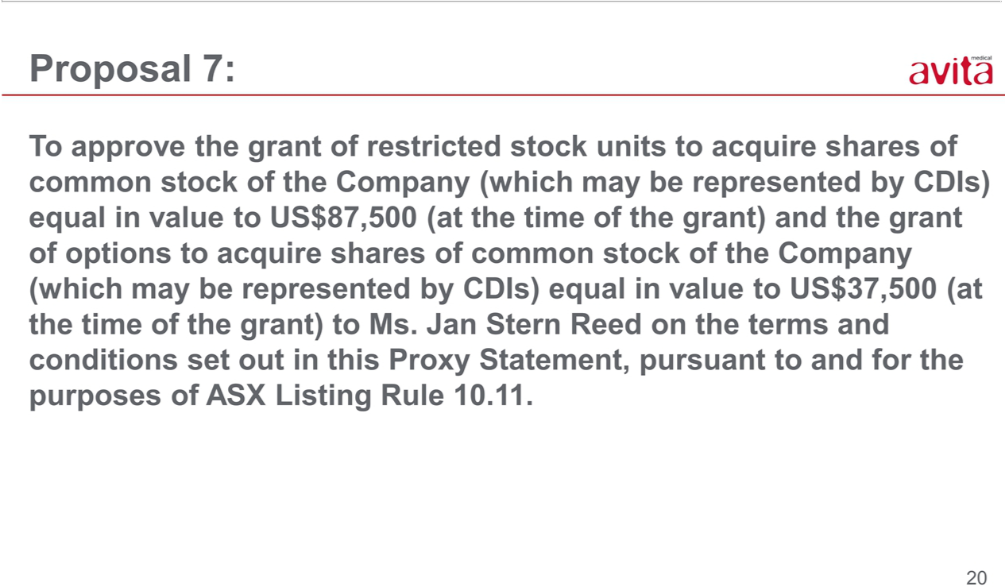

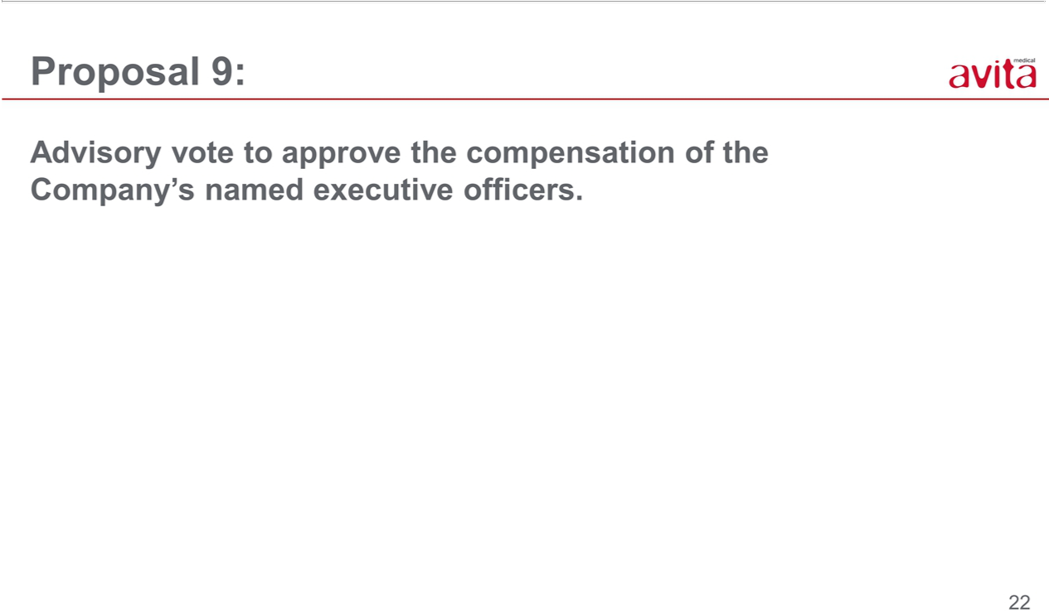

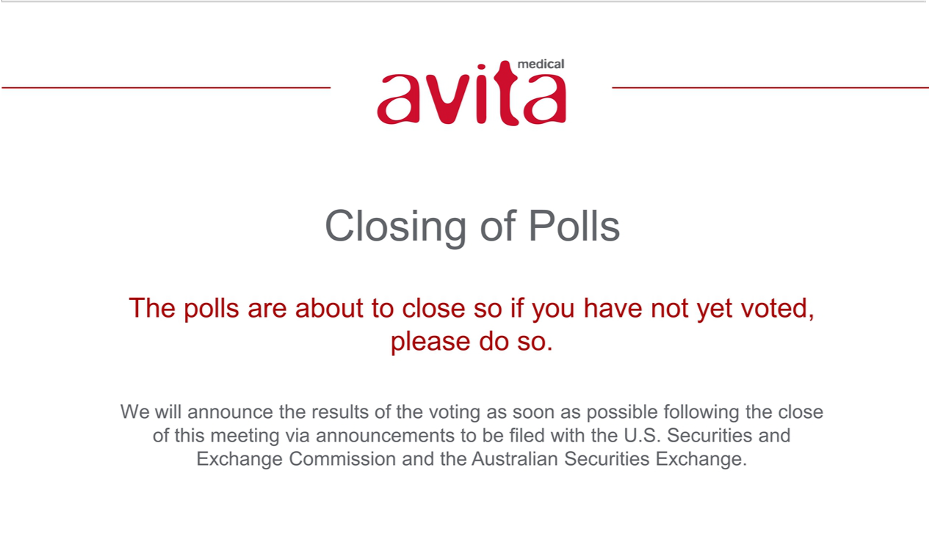

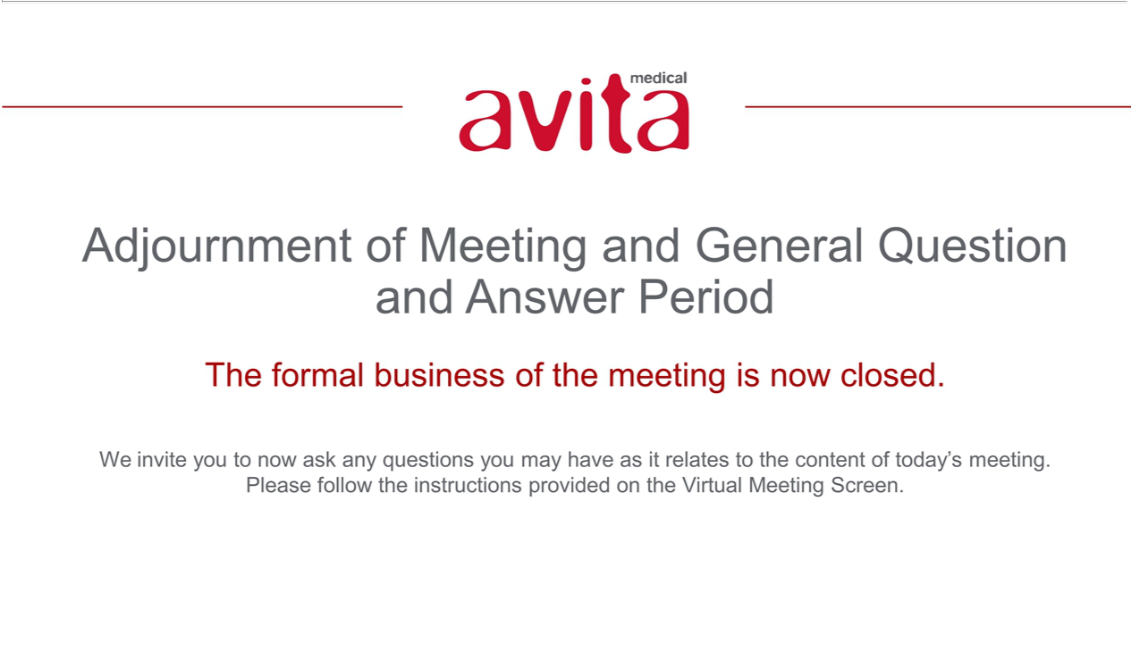



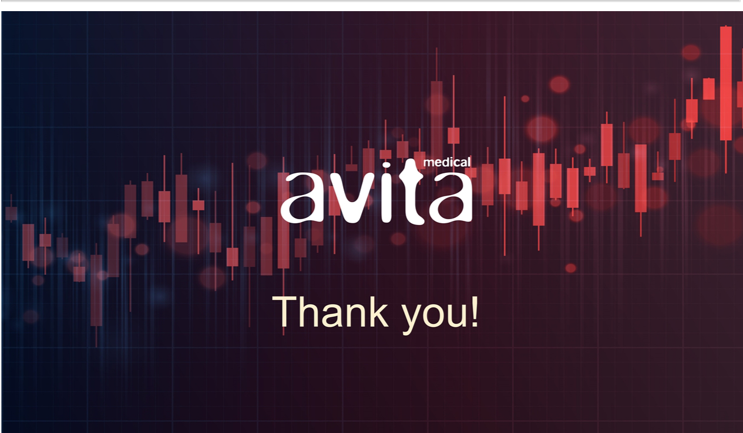

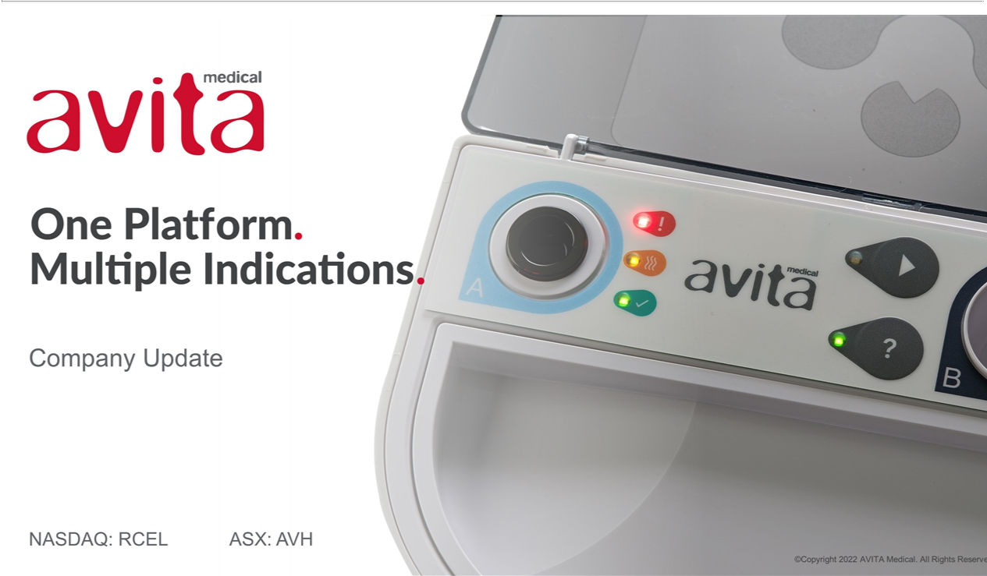

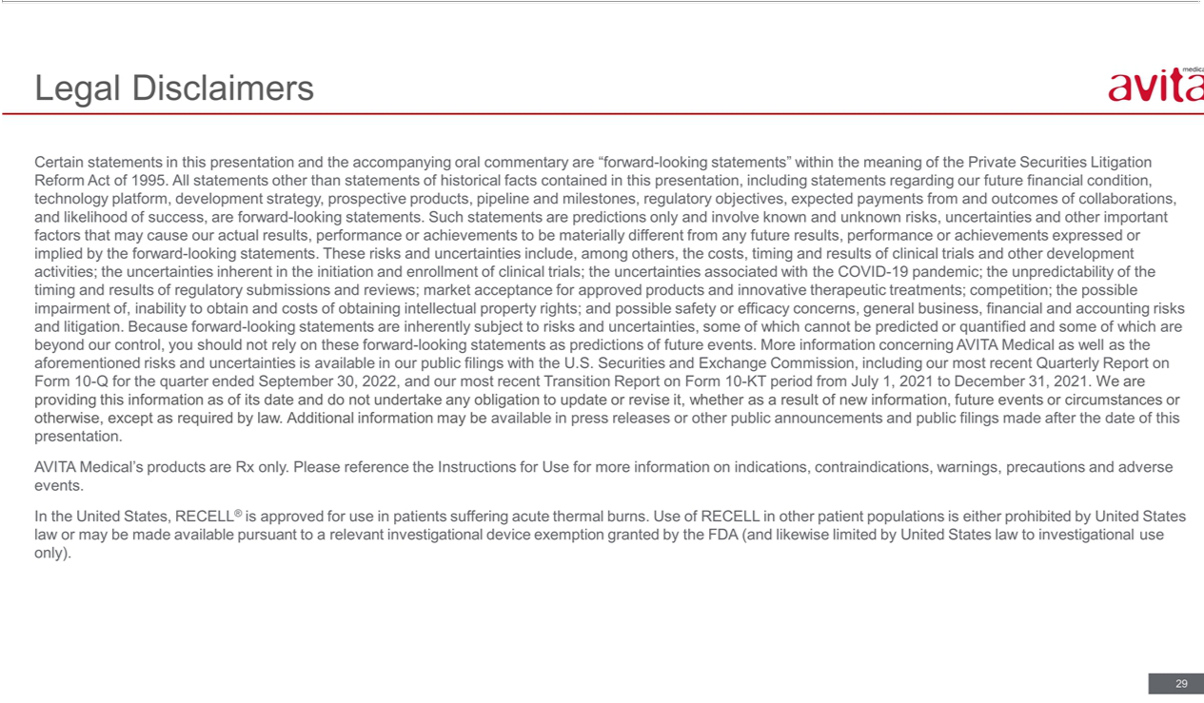

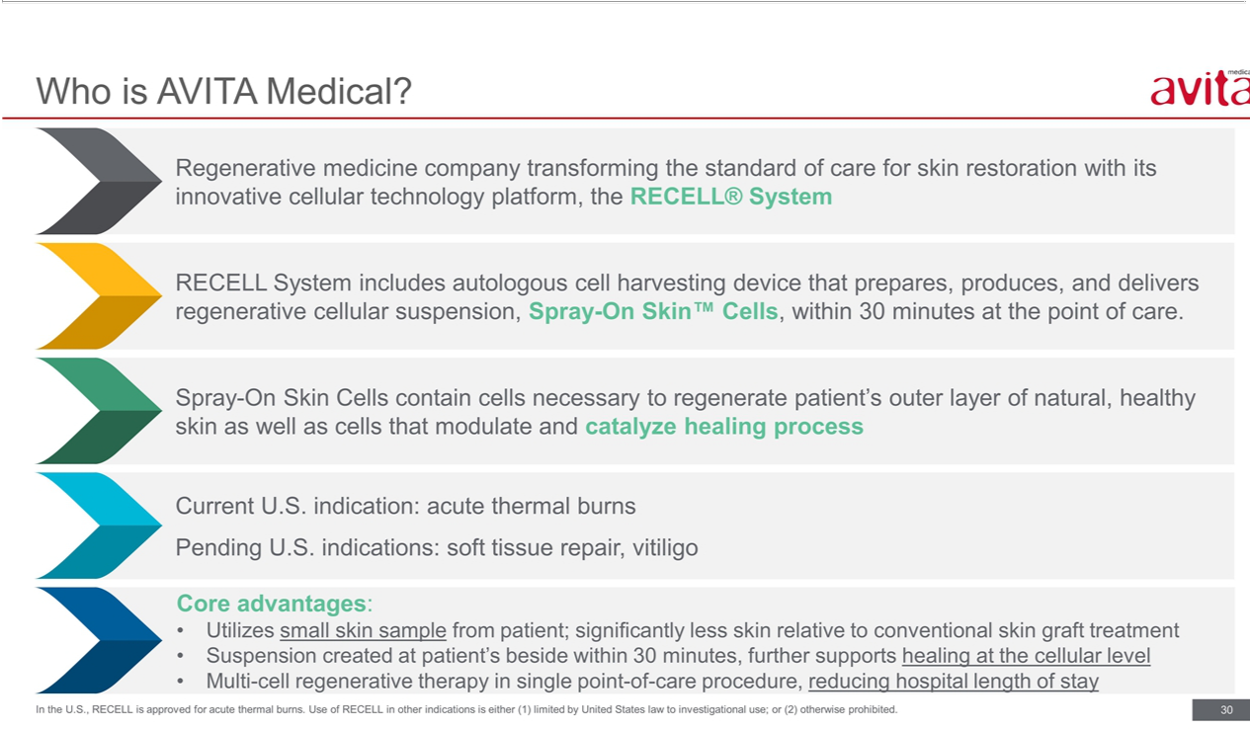

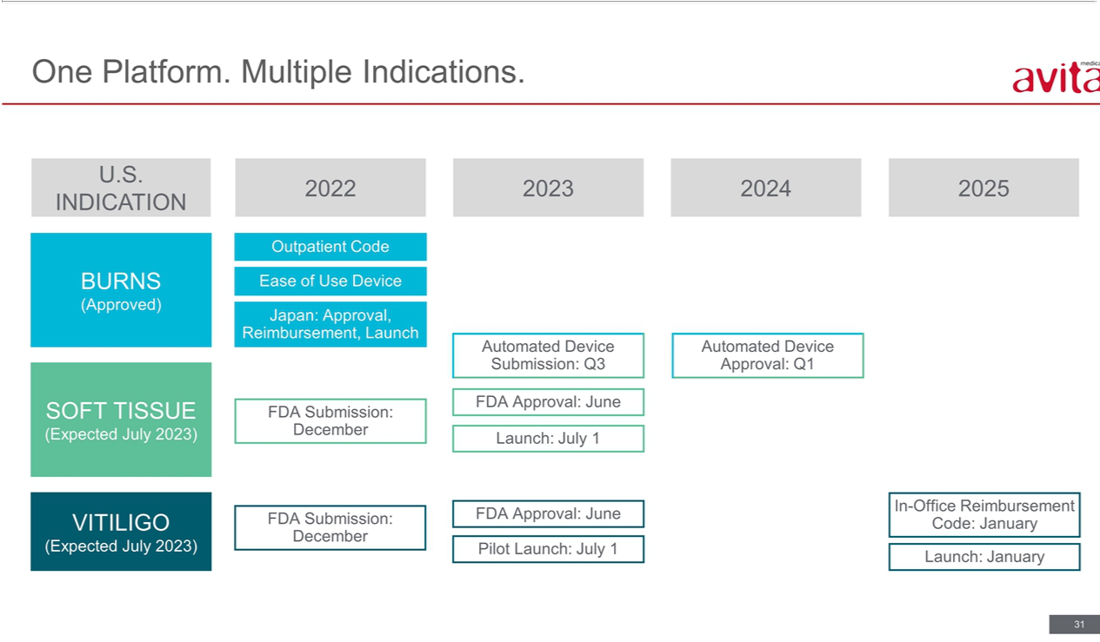

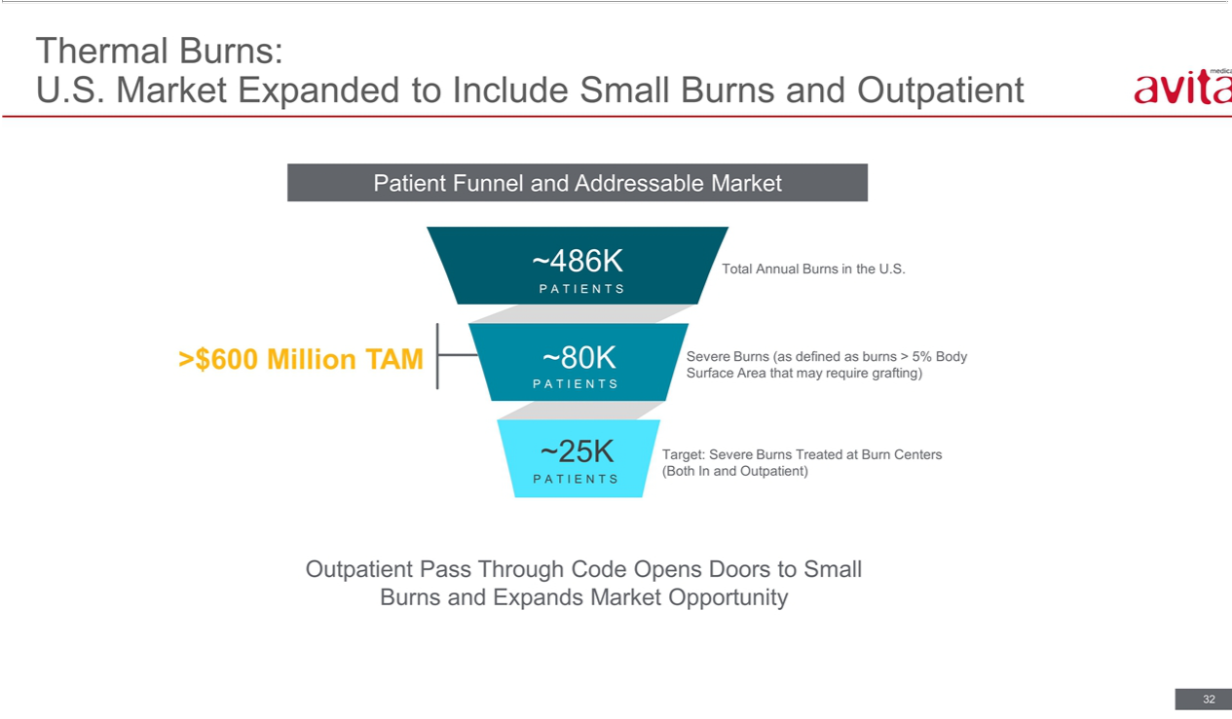

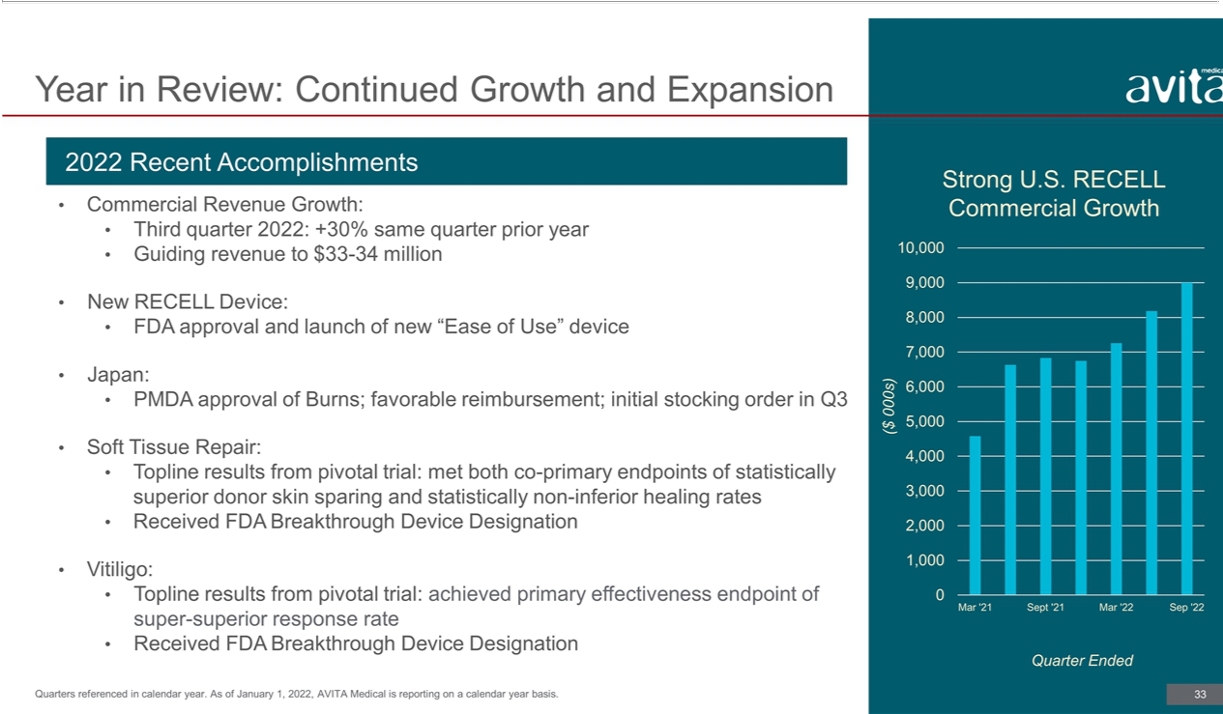

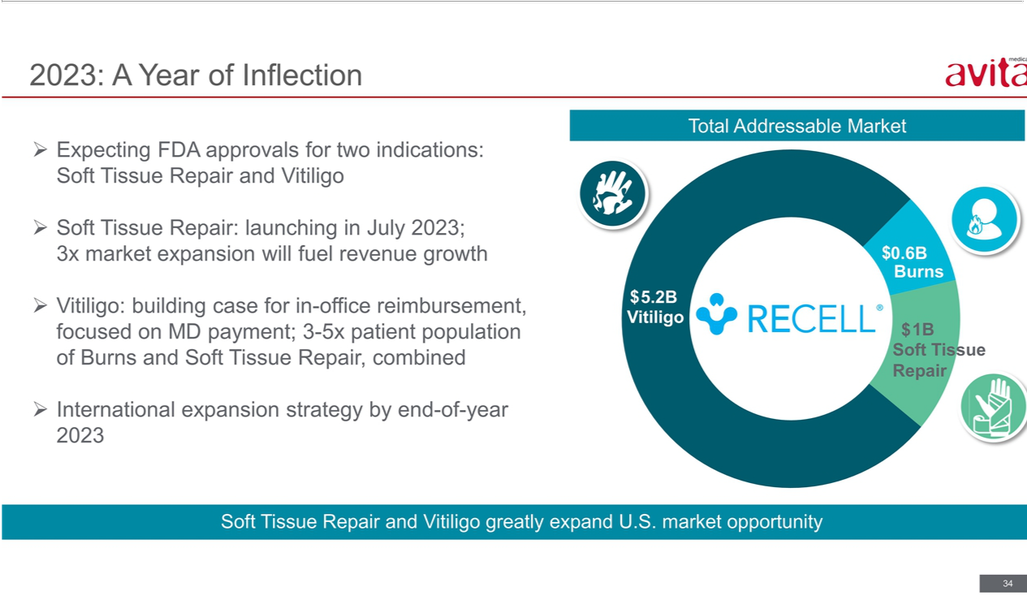

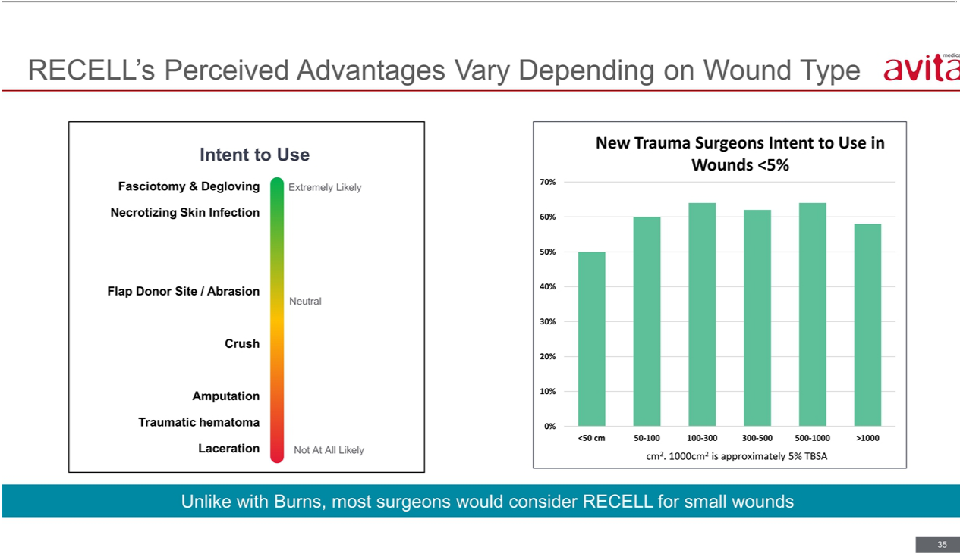

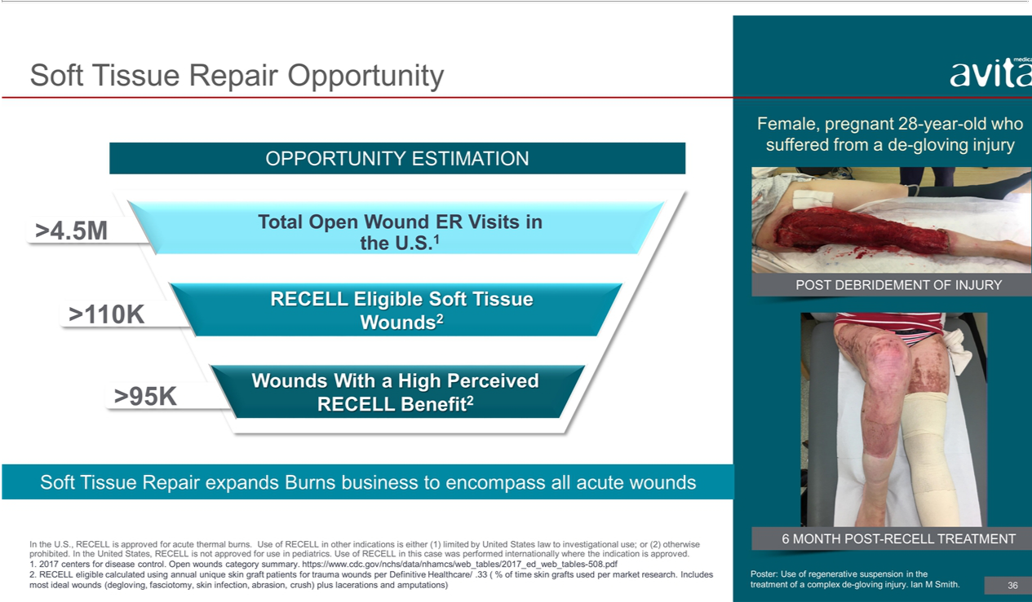

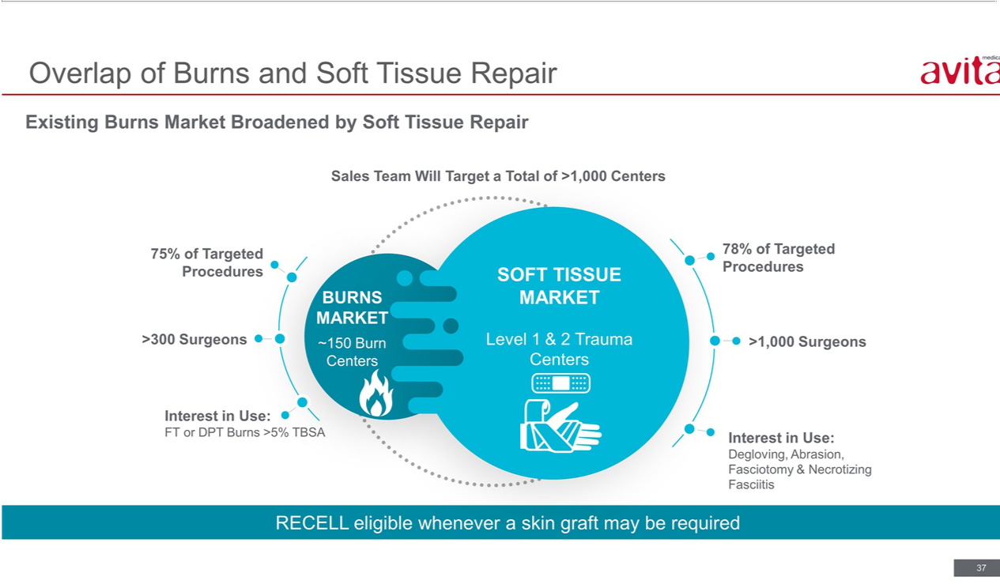

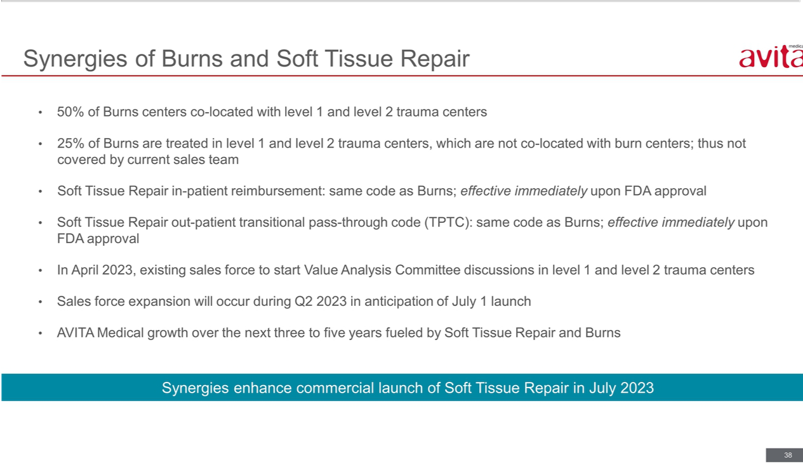

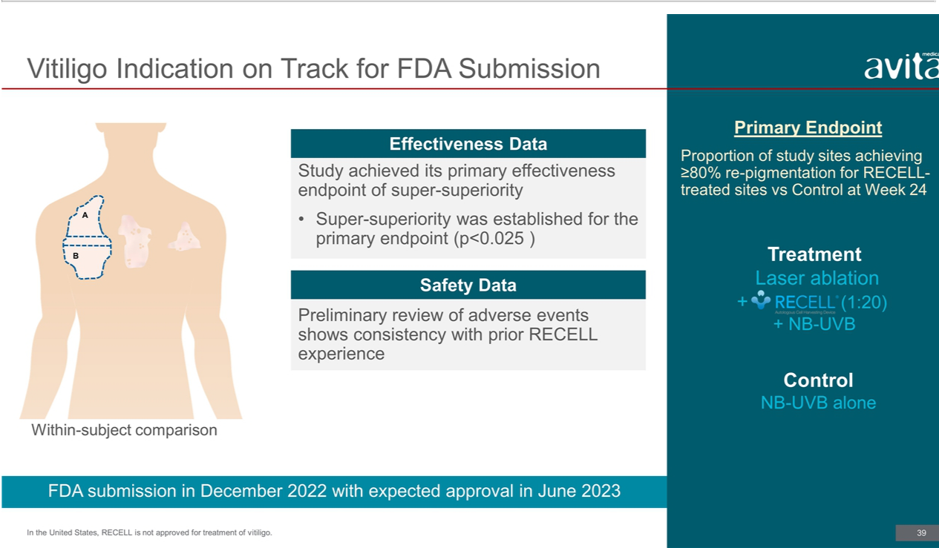

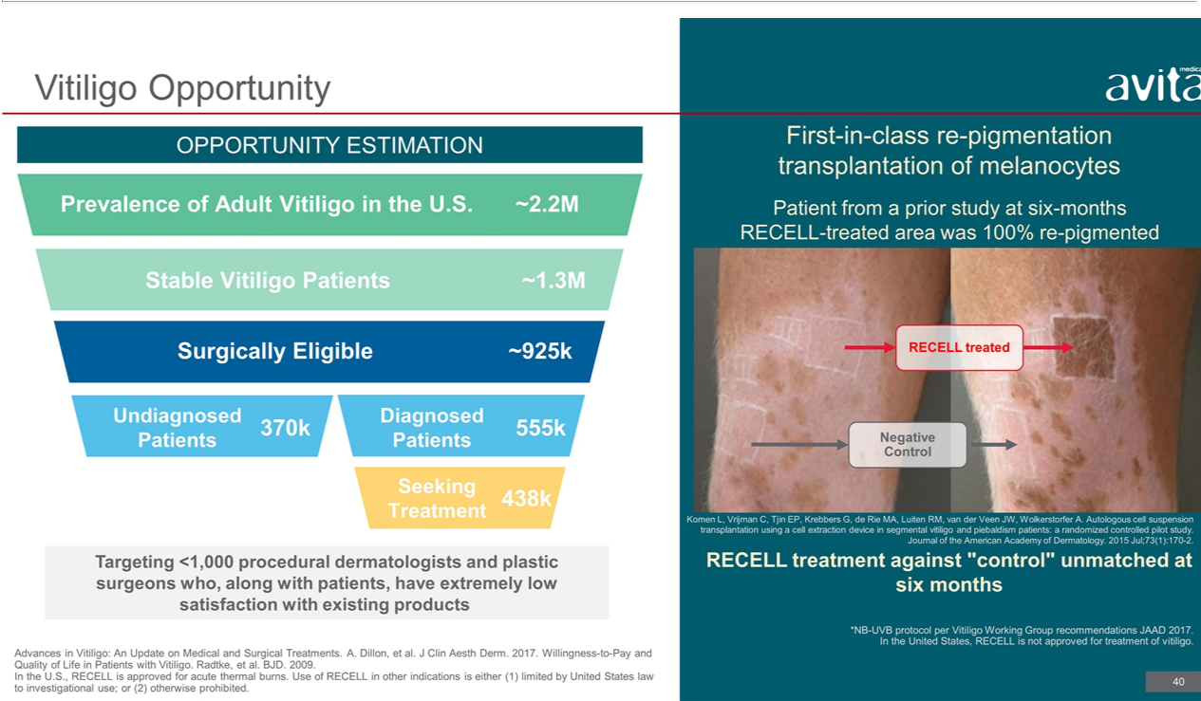

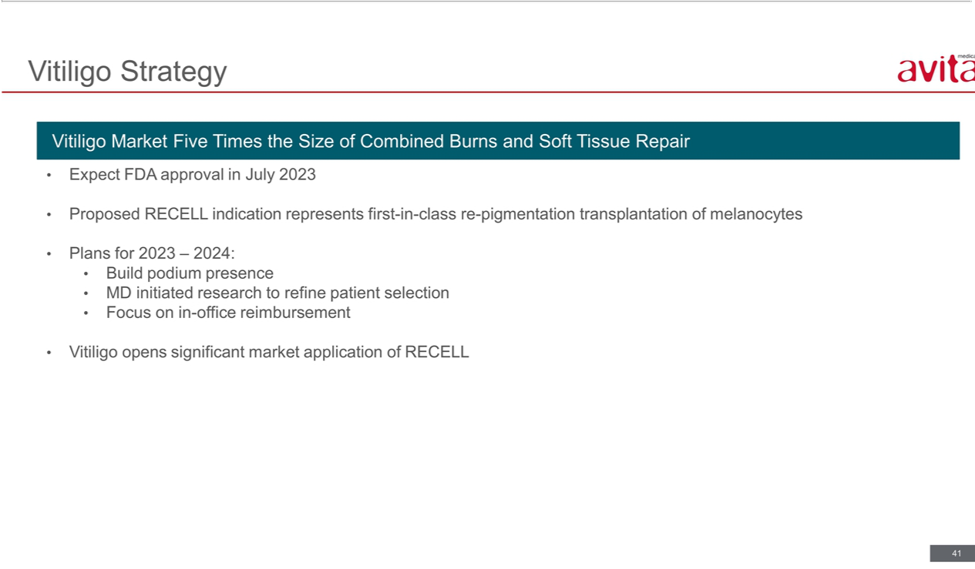

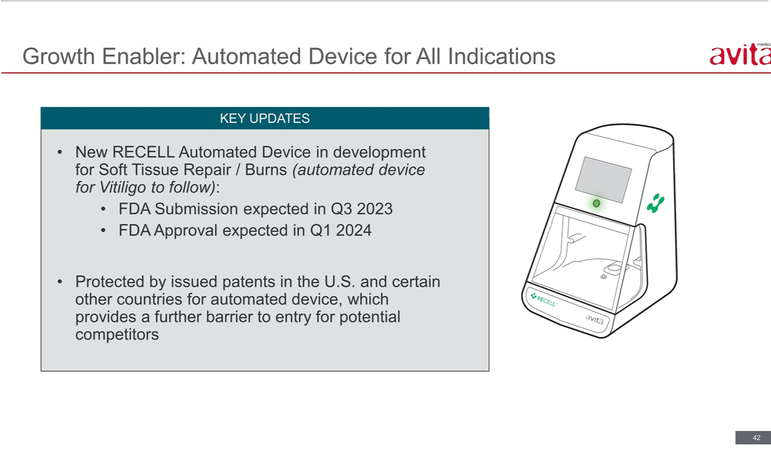

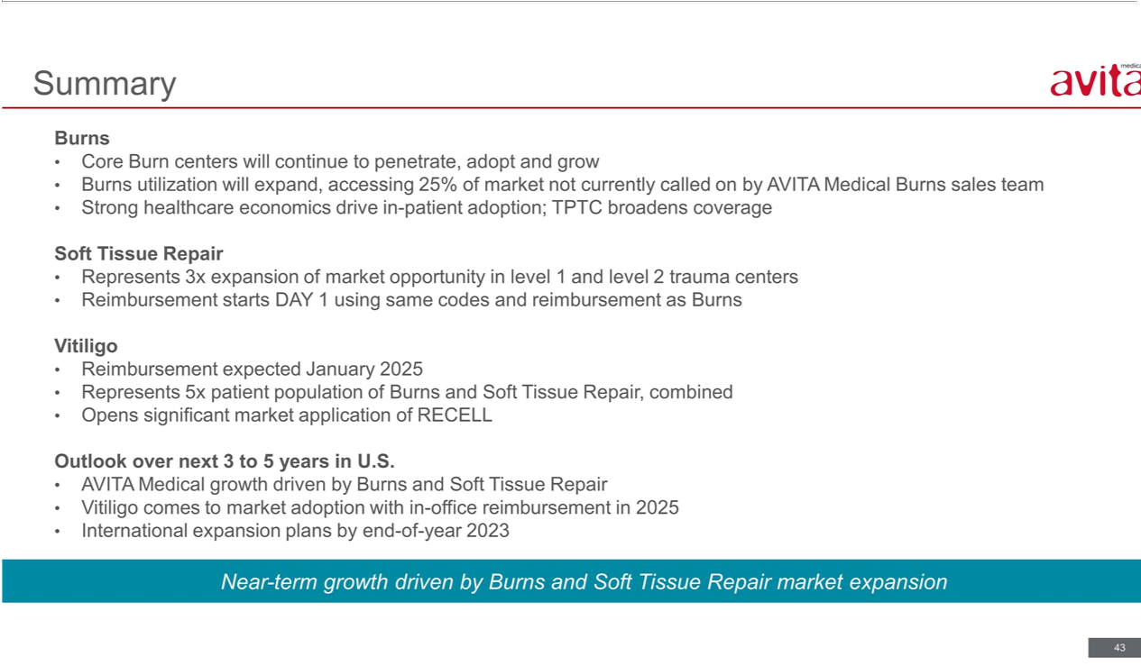

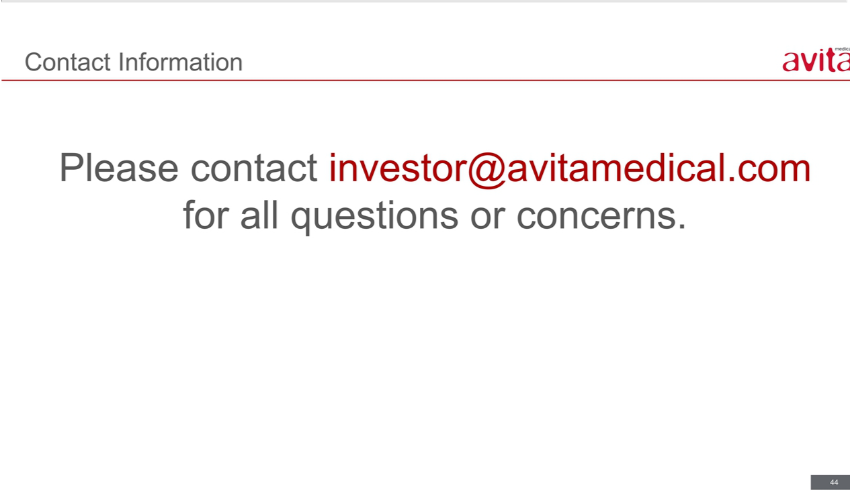



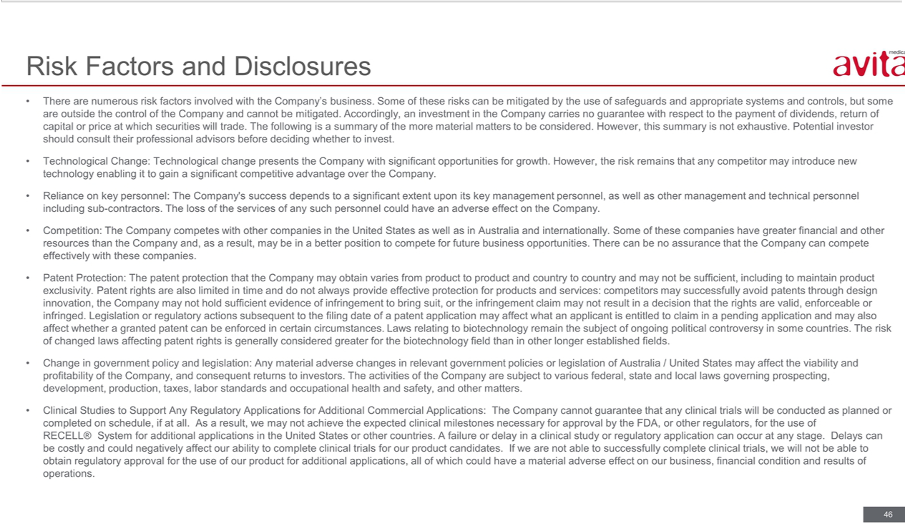

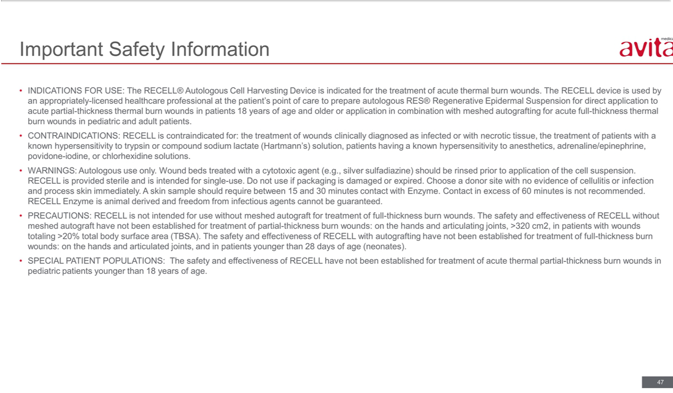

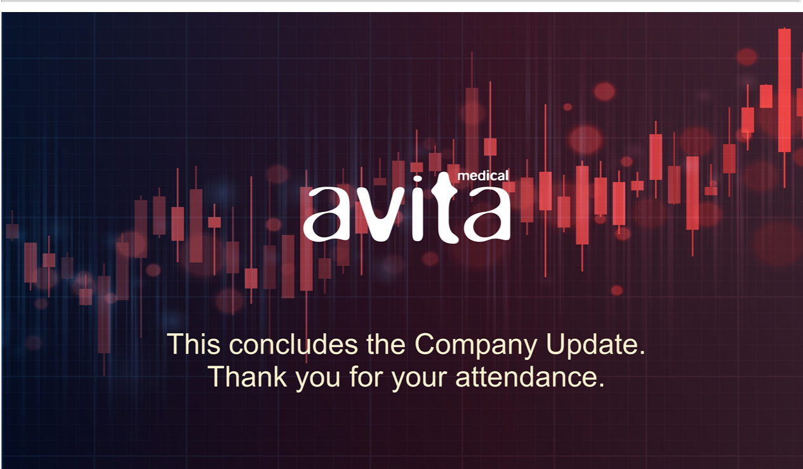

Exhibit 99.2


AVITA Medical Announces Results of 2022 Annual Meeting of Stockholders

VALENCIA, Calif. and MELBOURNE, Australia, December 12, 2022 (United States) / December 13, 2022 (Australia) (GLOBE NEWSWIRE)

— AVITA Medical, Inc. (NASDAQ: RCEL, ASX: AVH) (Company), a regenerative medicine company leading the development and commercialization of first-in-class devices and autologous cellular therapies for skin restoration, today announced the results of its 2022 Annual Meeting of Stockholders, which was held virtually on December 12, 2022 (United States) (being December 13, 2022 in Australia).

Election of Directors: All five directors named in the Company’s proxy statement dated October 19, 2022 (Proxy Statement) were elected or re-elected,

as applicable, to serve on the Company’s Board of Directors: Louis Panaccio, Chair; James Corbett, Executive Director and CEO; Professor Suzanne Crowe, Director; Jeremy Curnock Cook, Director; and Jan Stern Reed, Director.

Appointment of Independent Auditors: Stockholders approved the ratification of Grant Thornton LLP as the Company’s independent registered public accounting firm for the fiscal year ending December 31, 2022, as described in the Proxy Statement.

Amendments to the Company’s Amended and Restated Bylaws: Stockholders did not approve the proposal to amend the Company’s Amended and Restated Bylaws to reduce the quorum requirement for stockholder meetings, as the number of votes required to approve the proposal was not reached.

Issuance of Securities to Mr. Louis Panaccio: Stockholders approved the grant of restricted stock units to acquire shares of common stock of the Company (which may be represented by CDIs) equal in value to US$87,500 (at the time of the grant) and the grant of options to acquire shares of common stock of the Company (which may be represented by CDIs) equal in value to US$37,500 (at the time of the grant) to Mr. Louis Panaccio, on the terms and conditions set out in the Proxy Statement, pursuant to and for the purposes of ASX Listing Rule 10.11.

Issuance of Securities to Professor Suzanne Crowe: Stockholders approved the grant of restricted stock units to acquire shares of common stock of the Company (which may be represented by CDIs) equal in value to US$87,500 (at the time of the grant) and the grant of options to acquire shares of common stock of the Company (which may be represented by CDIs) equal in value to US$37,500 (at the time of the grant) to Professor Suzanne Crowe, on the terms and conditions set out in the Proxy Statement, pursuant to and for the purposes of ASX Listing Rule 10.11.

Issuance of Securities to Mr. Jeremy Curnock Cook: Stockholders approved the grant of restricted stock units to acquire shares of common stock of the Company (which may be represented by CDIs) equal in value to US$87,500 (at the time of the grant) and the grant of options to acquire shares of common stock of the Company (which may be represented by CDIs) equal in value to US$37,500 (at the time of the grant) to Mr. Jeremy Curnock Cook, on the terms and conditions set out in the Proxy Statement, pursuant to and for the purposes of ASX Listing Rule 10.11.

Issuance of Securities to Ms. Jan Stern Reed: Stockholders approved the grant of restricted stock units to acquire shares of common stock of the Company (which may be represented by CDIs) equal in value to US$87,500 (at the time of the grant) and the grant of options to acquire shares of common stock of the

Company (which may be represented by CDIs) equal in value to US$37,500 (at the time of the grant) to Ms. Jan Stern Reed, on the terms and conditions set out in the Proxy Statement, pursuant to and for the purposes of ASX Listing Rule 10.11.

Issuance of Securities to Mr. James Corbett: Stockholders approved the grant of options to acquire shares of common stock of the Company (which may be represented by CDIs) equal in value to US$1,000,000 (at the time of the grant) to Mr. James Corbett on the terms and conditions set out in the Proxy Statement, pursuant to and for the purposes of ASX Listing Rule 10.11.

Advisory Vote to Approve Compensation of Named Executive Officers: Stockholders voted in favor of the non-binding advisory vote to approve the compensation of the Company’s named executive officers.

The final votes have been reported in a Form 8-K that was filed with the Securities and Exchange Commission earlier today. The filing can be found on the Company’s website at https://ir.avitamedical.com/financials/sec-filings.

The voting results of the Annual Meeting of Stockholders for the purposes of ASX Listing Rule 3.13.2 are attached to this announcement.

Authorized for release by the Chief Executive Officer of AVITA Medical, Inc.

# # #

ABOUT AVITA MEDICAL, INC.

AVITA Medical® is a regenerative medicine company leading the development and commercialization of devices and autologous cellular therapies for skin restoration. The RECELL® System technology platform, approved by the FDA for the treatment of acute thermal burns in both adults and children, harnesses the regenerative properties of a patient’s own skin to create Spray-On Skin™ cells. Delivered at the point-of- care, RECELL enables improved clinical outcomes and validated cost savings. RECELL is the catalyst of a new treatment paradigm and AVITA Medical is leveraging its proven and differentiated capabilities to develop first-in-class cellular therapies for multiple indications, including soft tissue repair and repigmentation of stable vitiligo lesions.

AVITA Medical’s first U.S. product, the RECELL System, was approved by the U.S. Food and Drug Administration (FDA) in September 2018. The RECELL System is approved for acute partial-thickness thermal burn wounds in patients 18 years of age and older or application in combination with meshed autografting for acute full-thickness thermal burn wounds in pediatric and adult patients. In February 2022, the FDA reviewed and approved the PMA supplement for RECELL Autologous Cell Harvesting Device, an enhanced RECELL System aimed at providing clinicians a more efficient user experience and simplified workflow.

The RECELL System is used to prepare Spray-On Skin™ Cells using a small amount of a patient’s own skin, providing a new way to treat severe burns, while significantly reducing the amount of donor skin required. The RECELL System is designed to be used at the point of care alone or in combination with autografts depending on the depth of the burn injury. Compelling data from randomized, controlled clinical trials conducted at major U.S. burn centers and real-world use in more than 15,000 patients globally, reinforce that the RECELL System is a significant advancement over the current standard of care for burn patients and offers benefits in clinical outcomes and cost savings. Healthcare professionals should read the INSTRUCTIONS FOR USE - RECELL Autologous Cell Harvesting Device (https://recellsystem.com) for a full description of indications for use and important safety information including contraindications, warnings, and precautions.

In international markets, our products are approved under the RECELL System brand to promote skin healing in a wide range of applications including burns, soft tissue repair, vitiligo, and aesthetics. The RECELL System is TGA-registered in Australia, received CE-mark approval in Europe and has PMDA approval in Japan.

To learn more, visit www.avitamedical.com.

CAUTIONARY NOTE REGARDING FORWARD-LOOKING STATEMENTS

This press release includes forward-looking statements. These forward-looking statements generally can be identified by the use of words such as “anticipate,” “expect,” “intend,” “could,” “may,” “will,” “believe,” “estimate,” “look forward,” “forecast,” “goal,” “target,” “project,” “continue,” “outlook,” “guidance,” “future,” other words of similar meaning and the use of future dates. Forward-looking statements in this press release include, but are not limited to, statements concerning, among other things, our ongoing clinical trials and product development activities, regulatory approval of our products, the potential for future growth in our business, and our ability to achieve our key strategic, operational and financial goal. Forward-looking statements by their nature address matters that are, to different degrees, uncertain. Each forward-looking statement contained in this press release is subject to risks and uncertainties that could cause actual results to differ materially from those expressed or implied by such statement. Applicable risks and uncertainties include, among others, the timing of regulatory approvals of our products; physician acceptance, endorsement, and use of our products; failure to achieve the anticipated benefits from approval of our products; the effect of regulatory actions; product liability claims; risks associated with international operations and expansion; and other business effects, including the effects of industry, economic or political conditions outside of the company’s control. Investors should not place considerable reliance on the forward-looking statements contained in this press release. Investors are encouraged to read our publicly available filings for a discussion of these and other risks and uncertainties. The forward-looking statements in this press release speak only as of the date of this release, and we undertake no obligation to update or revise any of these statements.

This press release was authorized by the review committee of AVITA Medical, Inc.

FOR FURTHER INFORMATION:

Investors & Media

AVITA Medical, Inc.

Jessica Ekeberg

Phone +1-661-904-9269

investor@avitamedical.com

media@avitamedical.com

PR 2022AGM 12122022

# # #

AVITA Medical, Inc.

Annual Meeting of Shareholders

December 12, 2022 (United States) / December 13, 2022 (Australia)

Voting Results

The following information is provided for the purposes of ASX Listing Rule 3.13.2.

Resolution |  |  | Instructions given to validly appointed proxies |  |  |  |  |  |  |  |  |  |  |  |  |  | Resolution
details |  |  |  |  | (as at proxy close) |  |  |  |  |  | Number of votes cast on the poll |  |  |  |  |  | result
Resolution |  |  |  |  |  |  | Proxy’s |  |  |  |  |  |  |  |  |  | Carried /
Resolution |  |  | For |  | Against |  | discretion |  | Abstain |  | For |  | Against |  | Abstain* |  | not carried
Resolution 1: Election of Directors
to serve a one-year term |  | 9,299,761 |  |  | 0 |  | 0 |  | 1.685,226 |  | 9,299,761 |  | 0 |  | 1,685,226
Louis Panaccio, Non- Executive |  |  |  |  |  |  |  |  |  |  |  |  |  |  |  |  | Carried
Chairman of the Board of |  | 84.66% |  |  | 0% |  | 0% |  | 15.34% |  | 84.66% |  | 0% |  | 15.34%
Directors

Resolution 1: Election of Directors
to serve a one-year term | 10,360,740 | 0 | 0 | 624,247 | 10,360,740 | 0 | 624,247
James Corbett, Executive Director
and Chief Executive Officer | 94.32% | 0% | 0% | 5.68% | 94.32% | 0% | 5.68%
Resolution 1: Election of Directors
to serve a one-year term | 9,803,894 | 0 | 0 | 1,181,093 | 9,855,810 | 0 | 1,181,093
Jeremy Curnock Cook,
Non-Executive Director | 89.25% | 0% | 0% | 10.75% | 87.45% | 0% | 10.75%
Resolution 1: Election of Directors
to serve a one-year term | 9,216,541 | 0 | 0 | 1,768,446 | 9,216,541 | 0 | 1,768,446
Professor Suzanne Crowe,
Non-Executive Director | 83.90% | 0% | 0% | 16.10% | 83.90% | 0% | 16.10%
Resolution 1: Election of Directors
to serve a one-year term | 9,926,444 | 0 | 0 | 1,058,543 | 9,926,444 | 0 | 1,058,543
Jan Stern Reed, Non-Executive | 90.36% | 0% | 0% | 9.64% | 90.36% | 0% | 9.64%
Director
Resolution 2: To ratify the
appointment of Grant Thornton | 12,430,789 | 224,743 | 0 | 258,367 | 12,430,789 | 224,743 | 258,367
LLP as the Company’s
independent public accountants | 96.26% | 1.74% | 0% | 2.00% | 96.26% | 1.74% | 2.00%
for the fiscal year ending
December 31, 2022.

Carried


Carried

Carried

Carried

Carried

Resolution 3: To approve
amendments to the Company’s | 9,587,285 | 956,344 | 0 | 441,358 | 9,587,285 | 956,344 | 441,358 | Not
Amended and Restated Bylaws
to reduce the quorum | 87.27% | 8.71% | 0% | 4.02% | 87.27% | 8.71% | 4.02% | Carried**
requirement for stockholder

meetings.

Resolution 4: To approve the grant of restricted

stock units to acquire shares of common

stock of the Company (which may be

represented by CDIs) equal in value to

US$87,500 (at the time of the grant) and the

grant of options to acquire shares of

common stock of the Company (which may

be represented by CDIs) equal in value to

US$37,500 (at the time of the grant) to

Mr. Louis Panaccio on the terms and

conditions set out in this Proxy Statement,

pursuant to and for the purposes of ASX

Listing Rule 10.11.

Resolution 5: To approve the grant of restricted

stock units to acquire shares of common

stock of the Company (which may be

represented by CDIs) equal in value to

US$87,500 (at the time of the grant) and the

grant of options to acquire shares of

common stock of the Company (which may

be represented by CDIs) equal in value to

US$37,500 (at the time of the grant) to

Professor Suzanne Crowe on the terms and

conditions set out in this Proxy Statement,

pursuant to and for the purposes of ASX

Listing Rule 10.11.

Resolution 6: To approve the grant of restricted

stock units to acquire shares of common

stock of the Company (which may be

represented by CDIs) equal in value to

US$87,500 (at the time of the grant) and the

grant of options to acquire shares of

common stock of the Company (which may

be represented by CDIs) equal in value to

US$37,500 (at the time of the grant) to

Mr. Jeremy Curnock Cook on the terms and

conditions set out in this Proxy Statement,

pursuant to and for the purposes of ASX

Listing Rule 10.11.

Resolution 7: To approve the grant of restricted

stock units to acquire shares of common

stock of the Company (which may be

represented by CDIs) equal in value to

US$87,500 (at the time of the grant) and the

grant of options to acquire shares of

common stock of the Company (which may

be represented by CDIs) equal in value to

US$37,500 (at the time of the grant) to

Ms. Jan Stern Reed on the terms and

conditions set out in this Proxy Statement,

pursuant to and for the purposes of ASX

Listing Rule 10.11.

Resolution 8: To approve the grant of options to acquire shares of common stock of the Company (which may be represented by CDIs) equal in value to US$1,000,000 (at the time of the grant) to Mr. James Corbett on the terms and conditions set out in this Proxy Statement, pursuant to and for the purposes of ASX Listing Rule 10.11.

7,637,405 | 2,735,159 | 0 | 612,423 | 7,637,405 | 2,735,159 | 612,423
69.52% | 24.90% | 0% | 5.58% | 69.52% | 24.90% | Carried
 |  |  |  |  |  | 5.58%


7,656,800 | 2,666,551 | 0 | 661,636 | 7,656,800 | 2,666,551 | 661,636
69.71% | 24.27% | 0% | 6.02% | 69.71% | 24.27% | Carried
 |  |  |  |  |  | 6.02%

7,612,792 | 2,745,543 | 0 | 626,652 | 7,612,792 | 2,745,543 | 626,652
69.31% | 24.99% | 0% | 5.70% | 69.31% | 24.99% | Carried
 |  |  |  |  |  | 5.70%

7,657,643 | 2,674,563 | 0 | 652,781 | 7,657,643 | 2,674,563 | 652,781
69.71% | 24.35% | 0% | 5.94% | 69.71% | 24.35% | Carried
 |  |  |  |  |  | 5.94%

8,476,617 | 1,869,887 | 0 | 638,483 | 8,476,617 | 1,869,887 | 638,483
77.17% | 17.02% | 0% | 5.81% | 77.17% | 17.02% | Carried
 |  |  |  |  |  | 5.81%

Resolution 9: Advisory vote to approve the | 7,832,181 | 2,381,954 | 0 | 770,852 | 7,832,181 | 2,381,954 | 770,852
compensation of the Company’s named |  |  |  |  |  |  | Carried
executive officers. | 71.30% | 21.68% | 0% | 7.02% | 71.30% | 21.68% | 7.02%

- Votes relating to a person who abstained on Resolution 1 or any of Resolutions 4 - 8 (as applicable) were not counted in determining whether or not the required majority of votes were cast for or against that Resolution. Votes relating to a person who abstained on Resolutions 2, 3 or 9 (as applicable) were counted as votes “AGAINST” that Resolution in determining whether or not the required majority of votes were cast for or against that Resolution.

- Resolution 3 was not carried as the number of votes required to approve the proposal was not reached.

