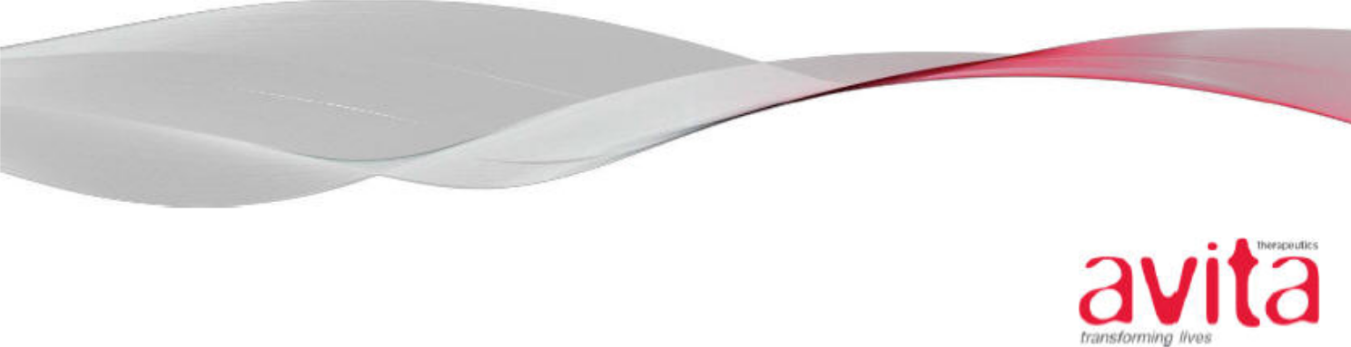

October 15, 2020

VIA EDGAR

United States Securities and Exchange Commission

Division of Corporate Finance

100 F Street, N.E.

Washington, DC 20549-4628

Re: Avita Therapeutics, Inc. (the “Company”)

Registration Statement on Form S-3

Filed October 9, 2020

File No. 333-249419

Ladies and Gentlemen:

Pursuant to Rule 461 under the Securities Act of 1933, Avita Therapeutics, Inc. (the “Company”) hereby requests that the effectiveness of the above-captioned Registration Statement be accelerated to October 16, 2020, at 4:00 p.m., Washington, D.C. time, or as soon thereafter as practicable.

The Company hereby acknowledges that:

- Should the Commission or the staff, acting pursuant to delegated authority, declare the filing effective, it does not foreclose the Commission from taking any action with respect to the filing;

- The action of the Commission or the staff, acting pursuant to delegated authority, in declaring the filing effective, does not relieve the Company from its full responsibility for the adequacy and accuracy of the disclosure in the filing; and

- The Company may not assert this action as a defense in any proceeding initiated by the Commission or any person under the federal securities laws of the United States.

If you have any questions, or require any additional information, please do not hesitate to call Christopher H. Cunningham at K&L Gates LLP, the Company’s primary outside counsel, at (206) 370-7639.

Very truly yours,

Avita Therapeutics, Inc.

Donna Shiroma

General Counsel

- Christopher H. Cunningham, K&L Gates LLP


